Secondary CTE Enrollment Reporting 2025-26
Submission Deadline: July 31, 2026
This file format is only for secondary CTE programs approved for high school level students. Do not use it to report students in middle school or postsecondary level CTE programs. If you have any questions about which students to report on, please contact CCCS.

Contents (Ctrl + click on a title to go to that section in this document)
Secondary Enrollment General Instructions
How to Determine Which Students to Report and How to Report them
Secondary Enrollment File Format
Secondary Enrollment Frequently Asked Questions (FAQ)

General Information

What is CTE Enrollment reporting?
CTE enrollment data contains demographic and programmatic information for secondary and postsecondary level career and technical education (CTE) students. There are two principal components of reporting on CTE students, which are the “Enrollment” and “Follow-up” files. Because of its ties to continued federal and state funding for CTE programs, it is critical that the data be timely, valid, complete, and reliable. All CTE data submitted to CCCS is subject to audits internally, by the state, and by multiple federal agencies

How is CTE student data used and why is it required?
- Perkins Formula Allocation Grants – CTE student enrollment data is used in a portion of the formula, which calculates the distribution of federal Perkins funds to secondary and postsecondary institutions. Perkins formula allocations are reported to the schools by CCCS in the spring of each year.
- Federal Performance Reports – CTE student information is used for the federal performance report (Perkins performance metrics) due in December of each year to the US Department of Education and also dispersed to local recipients each spring to address in their Perkins local plans. This report uses information on special populations, gender, ethnicity, and program participation, concentration, and completion information.
- Colorado Technical Act - The secondary CTE data is used to generate the Colorado Technical Act (CTA) report, which is required by the state legislature each year. This report contains information on CTE programs including enrollment, completion, placement, costs, FTE, and other items.
- Program Approval & Renewal Process - The CTE student data populates three separate 5-year trend reports used by CCCS to evaluate new and existing CTE programs as set forth by the State Board for Community Colleges and Occupational Education (SBCCOE).
- Civil Rights Compliance Audits - The CCCS internal audit department uses the CTE student information to determine which schools should be visited in a compliance visit as mandated by the U.S. Department of Education, Office for Civil Rights. Selection can include such factors as concentrations of special populations, region, size, and time of the last visit.
- Other CCCS Reports - Many other reports are produced internally throughout the year for CCCS staff in order to maintain as well as continually improve and promote CTE in the state of Colorado.

CTE Student Enrollment
The CTE student enrollment submission for most secondary institutions is created in early summer following the close of each academic year. The process involves collecting demographic and program participation, concentration, and completion status for students taking CTE courses. The due date for secondary enrollment is July 31st of each year.

CTE Student Follow-up
The CTE student follow-up data is due March 31st of each year. The follow-up process involves the gathering of placement information on students who concentrated or completed a CTE program in the previous year.

What is the privacy policy of CTE student records at CCCS?
Aggregated data reports derived from CTE student records are considered to be public information with most reports mandated as such by the federal Perkins Act. Individual student records are protected in accordance with the Family Education Rights & Privacy Act (FERPA) and other established policies.

File Instructions
Please read all the instructions and file layout below carefully before starting your file. Don’t just build your file based on only the table layout. It is likely to save you time, limit frustration, and help to ensure that your data is complete and accurate in the long run.
- You should only report data for secondary level programs in this file. Use the most current guidance and template to create a data file of students to report to CCCS for the purpose of completing required accountability reporting for your secondary level CTE programs for the 2025-2026 academic year. The correct Excel template and Guidance can be found in the Gateway under Menu/Data Collection/Enrollment.
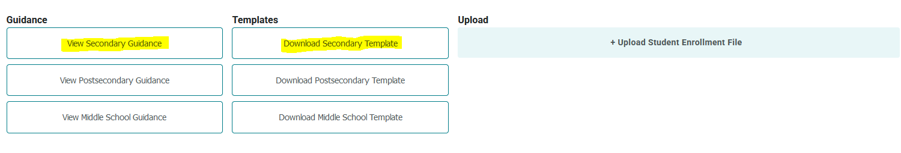
- You must use the current CCCS (not CDHE) assigned CTE CIP code and five-digit program Base ID (not Instance ID) for your secondary level CTE programs. The up-to-date CIP codes and program base IDs are listed in Gateway under Data Collection/Enrollment. Invalid CIP codes and program IDs will result in errors during validation.
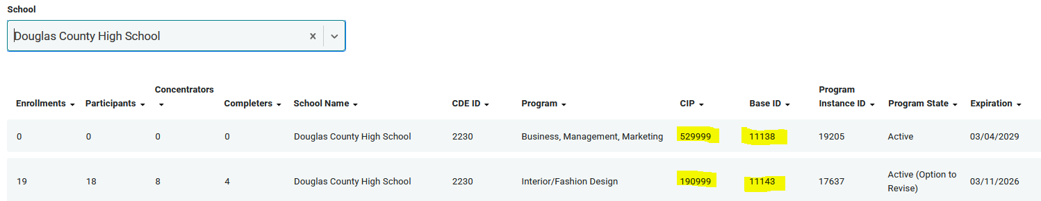
- It is extremely important that you provide accurate and complete student demographic information for all student records. Accountability mandates require that we perform data matching on the records that you provide with CDE (Colorado Department of Education) and other state and federal agencies. If records cannot be matched because of incorrect information, your program approval and/or funding could be jeopardized. The data you report is also subject to audits conducted by our office, the state, or by federal auditing agencies.
- Race/Ethnicity: You must use the same race/ethnicity data on students that you report to the CDE for October count and End of Year reporting. In addition, it’s important to note that you must complete the “Hispanic” field for all records (refer to the codes for a yes or no). In addition, you must also report a non-zero code for at least one (you may pick more than one) Race from the five Race fields: “American Indian”, “Asian”, “Black”, “White”, or “Pacific Islander” for all records. Thus, even if you report that a student is Hispanic for the ethnicity, then you also have to pick at least one race. If you aren’t sure, select “White”.
- Student Names: You should use the same first name, middle name, last name, and date of birth in this enrollment file that you report to CDE. This will greatly facilitate the mandated data matching processes mentioned above. Note that there should be no punctuation included in the data such as hyphens or apostrophes. These can cause mismatches with the CDE.
- SASID is Mandatory. The state assigned SASID/RITS ID is required for ALL secondary school student enrollment records. This is the unique 10-digit ID number that CDE assigns to every K-12 student when they enter the Colorado public education system. You can find a student's SASID by first contacting your district office. Every public school district in Colorado has a SASID contact person. If for some reason, you still cannot locate this contact person for your district, then you may contact CDE staff in Data Services at 303-866-6612.
- If you need assistance, a helpful reporting resource in your district would be those who are familiar with End of Year (EOY) submission process, as we rely on many of the same fields.
- Use Excel to assemble your student file following the file layout guidelines below. Note that the header names and order must match the student file layout as indicated or it will not upload into the Colorado CTE Gateway. Once you have assembled your file, you can either upload the completed spreadsheet or use the manual entry method on the website. We recommend the manual entry method if there are fewer students to report; otherwise, we recommend the file upload.

Records to Include in Your File
You should report only one record per student per program per school. Thus, if John Smith was enrolled in a Business, Agriculture, and a Health Sciences program all at Lincoln High School, then you should provide 3 total records in your enrollment submission--one record for each of the programs he was enrolled in with its distinct CIP and Program ID. You cannot report students in the enrollment file by course. If your file has multiple records for a student in the same CIP and Program ID at the same school, you will receive errors during the validation process and will have to remove those extra records.
Student records that you should include in your secondary enrollment file should meet the following criteria:
- They were enrolled in a high school level (secondary) CTE program during the 2025-26 school year. All enrolled students, regardless of whether they meet the definition of participant, concentrator, or completer below, should be included in your student file.
- They received transcriptable credit for courses taken.
- The coursework was taught by an appropriately credentialed instructor. If the student took courses taught within a single CTE program by a mix of credentialed and non-credentialed instructors, you can only count those taken by credentialed instructors.

Steps for Capturing Participants, Concentrators, and Completers
Once you have assembled your student records along with their demographic information, the next step is to mark them appropriately as Participants, Concentrators, and Completers. When calculating credit, you should use cumulative credits earned over time in a single CTE program to determine the concentrator and completer status. See the examples below for calculating credit and unique situations you may run into.
- Mark the student as a participant if they are a secondary student who has earned credit for one (1) or more courses within a CTE program, where course is defined as one Carnegie Unit of credit. This would be a student who has completed at least one year-long course, a student who has completed two semester-long courses, or any equivalent.

- Mark the student as a concentrator if they are a secondary student who has reached the point this reporting year of earning credit for two (2) or more Carnegie Units within a pathway in your CTE program approval. This would be a student who has completed at least two year-long courses, a student who has completed four semester-long courses, or any equivalent.

- All concentrators should also be flagged as a participant, since they have exceeded the participant threshold as well as the concentrator threshold.

- Mark the student as a completer if they have reached the point this reporting year of completing all or 100% of the requirements of at least one completer pathway as defined in your program approval. If there is flexibility in the pathway, where two or more courses are options for the same level of content, the student has to reach the point this reporting year of completing the series of courses that satisfies each option.
- All completers would also be flagged as a participant and concentrator, since they have exceeded both thresholds.

Examples of Student Participation, Concentration, and Completion Calculation
Calculating Cumulative Credit: John Smith took two semesters of welding his sophomore year 23-24, none his junior year 24-25, but returned his senior year for two additional semesters of welding in 25-26. How should John Smith be marked in each year’s enrollment file?
- In the 23-24 enrollment file, John Smith would be marked as a participant because he was enrolled that year and reached one year of credit.
- In the 24-25 enrollment file, John Smith would not be included as he wasn’t enrolled in a CTE program that year.
- In the 25-26 enrollment file, John Smith would be marked as a concentrator because he was enrolled that year and reached two years of credit. He would also be marked as a participant because he already reached that threshold. If the four semesters of classes he took also fulfilled the requirements of a Welding pathway as defined in the program approval, then he would also be marked as a completer.

Calculating Cumulative Credit (Transfers): Jane Smith was enrolled in the fall semester at Lincoln High and took one course in the Agriculture program. She then transferred to Washington High for the spring semester and took another course in the Agriculture program there. How should Jane Smith be marked in each enrollment file?
- If each of the courses Jane took are included in the pathway for the Agriculture programs at BOTH schools, then Jane should only be included as enrolled for Washington High and marked as a participant. This would be the most advantageous way to report for the program.
- If the course Jane took at Lincoln High is only included in the Agriculture pathway for Lincoln but not Washington, then Lincoln should report her as enrolled but not mark her as a participant and Washington should do the same. Neither would mark her as a participant because she hasn’t reached that status within either program pathway yet. If the course she took at Lincoln High is also in the pathway for Washington High, then only Washington High should report her and list her as a participant.

.

Calculating Cumulative Credit (Home vs CTE School): Sam Smith took two semesters of Business at his Home School of Littleton as a sophomore in 23-24, took two semesters of Business at his Home School of Littleton as a junior in 24-25, and also took one year of Vehicle Maintenance at Sheridan as a junior in 24-25 and a year of Vehicle Maintenance at Sheridan as a senior in 25-26. How should Sam Smith be marked in each school’s enrollment file for each year?
- For Littleton, his Home (Academic) school, he should be counted as enrolled in Business in 23-24 and marked as a Participant for achieving one year of credit.
- For Littleton, his Home (Academic) school, he should be counted as enrolled in Business in 24-25 and marked as a Concentrator for achieving two years of credit and also as a Participant because he’s already achieved that status.
- For Littleton, his Home (Academic) school, he should not be counted as enrolled in Business in 25-26 as he didn’t take any additional Business classes.
- For Sheridan, his CTE school, he should be counted as enrolled in Vehicle Maintenance for 24-25 and marked as a Participant for achieving one year of credit. He would not be counted at his Home School Littleton.
- For Sheridan, his CTE school, he should be counted as enrolled in Vehicle Maintenance for 25-26 and marked as a Concentrator for achieving two years of credit, and also as a Participant because he’s already achieved that status. He would not be counted at his Home School Littleton.
- For Littleton or Sheridan, he should be counted as a completer as well if he took enough credit to complete the pathway for either Business or Vehicle Maintenance.
- It’s important to note that in Sheridan’s file for both years, the HOMECDE_ID for Sam’s record would be the CDE code for Littleton and the CDE_ID would be the CDE code for Sheridan. This is how the distinguishment is made for students attending programs at multiple schools.

A note about Secondary Completers and Pathways:

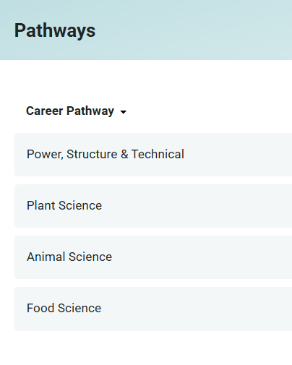
First, it’s important to note that it is Concentrators who drive all Perkins Performance Metrics and not Completers, as it was prior to 2000. When to mark a student as a completer can be confusing. Here are some examples to help guide you.
Example 1: Susie Smith is enrolled in Agriculture and completes Intro to Ag A and B her freshman year, Principles of Animal and Vet Science and Intermediate Vet Science A and B her sophomore year, Ag Leadership and Capstone her junior year, and WBL her senior year. Susie is not a completer until her senior year when she has completed the entire Animal Science pathway.
Depending on how your program is structured, you may never have completers in your pathway, and that is okay. Again, completers are not used in any Perkins V indicators for secondary students. The completer is an informative field that lets you know how successful your program is at progressing students through completion.
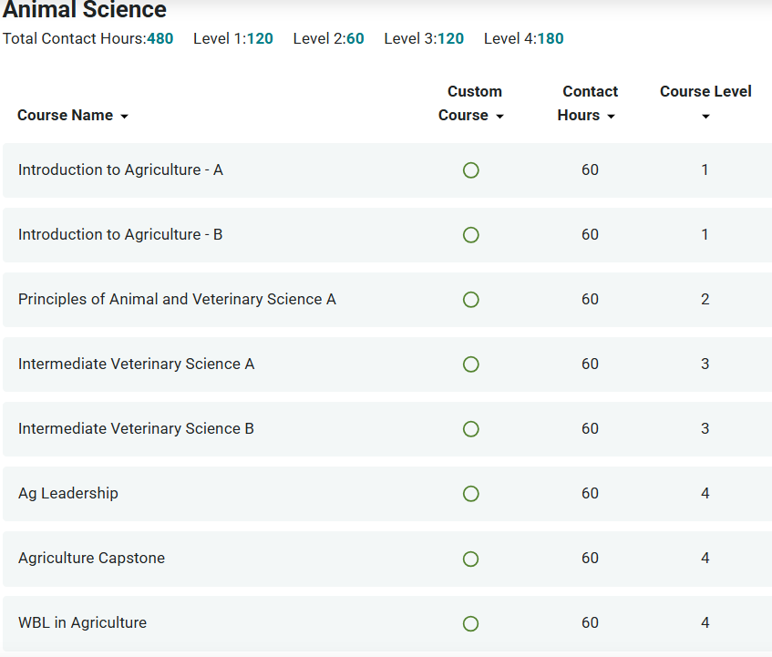

Final Checks on your Excel File

- Make sure that you clean out any duplicate records for a single student where they are listed with the same CTE CIP code. This can happen if you accidentally added records by course and didn’t roll up the credits into one program line. There should only be one record for each student per program.
- Make sure all columns conform to the file format guidance below and that all required fields are complete. It is also a best practice before uploading the file to have some records checked and the file reviewed internally.

Uploading and Validating Your Data

- Once you have finalized your file, you are ready to upload it to the Data Collection>Enrollment section of ColoradoCTE.com. Use the upload file button to import files. Do not email or mail your data file(s) to CCCS! Once your file is uploaded, it will be imported into the CTE data system and you will be able to review the results within 24 hours. You’ll have the opportunity to update the data (up to the July 31 deadline) with another file if you find that you need to amend records. (Note that updating records is only possible if your entity has not “certified” its records are complete and accurate in the Gateway. Do NOT certify your submission as complete until all records have been uploaded and checked for accuracy!)

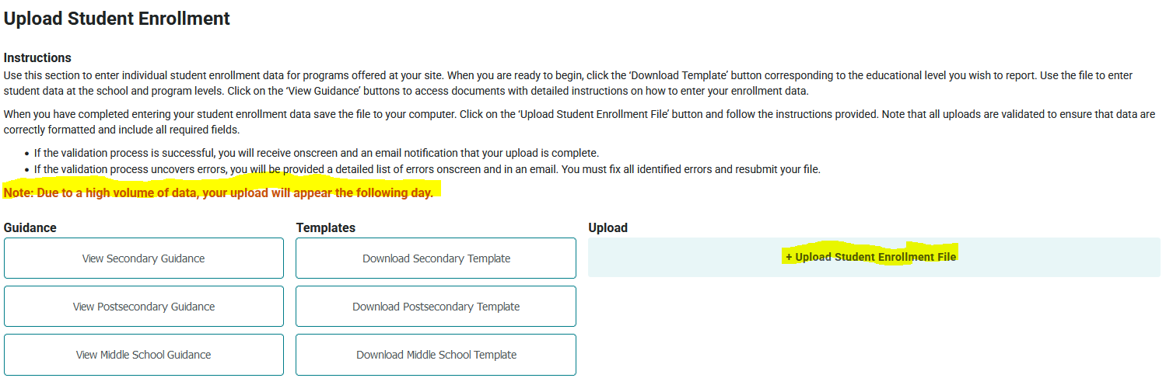

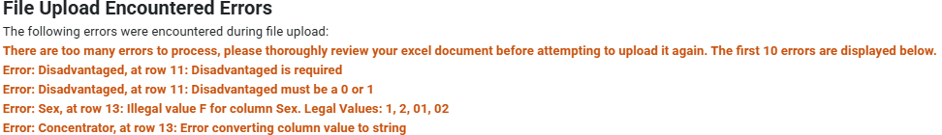
- When you upload a file, you will see an onscreen error log of the first 10 errors in the file, as well as receive an email with the list of errors. Your file will not be accepted for import until all errors are corrected.

- A note about deleting students: If you add a student manually or to your file upload in error, simply removing them from the file and reuploading will NOT remove them from the Gateway. To remove a student, you must go into the program and delete the student manually as shown below.

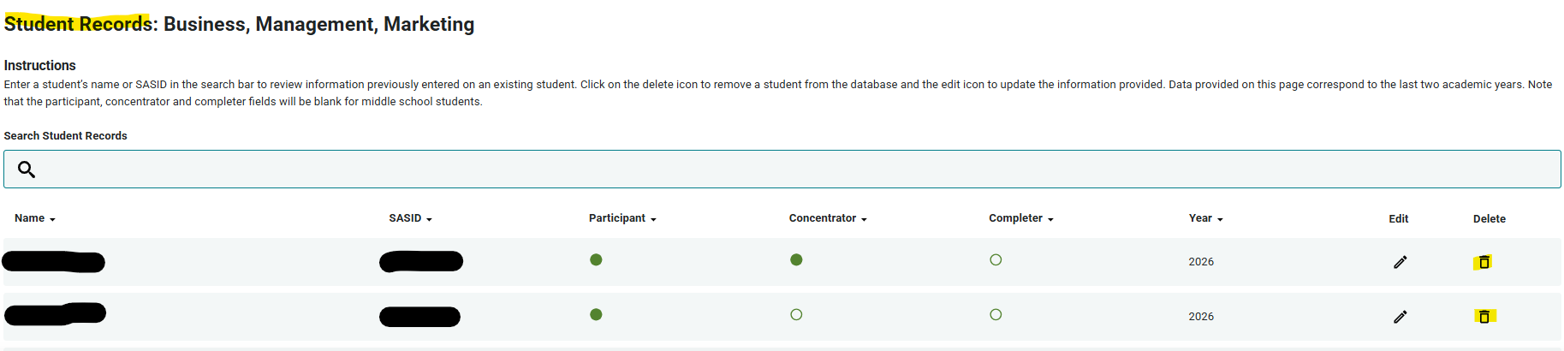

- A note about INACTIVE programs. The Gateway should allow you to report enrollment and follow up for any program that was active at some point between July 1, 2025, and June 30, 2026. Should you encounter an error, please submit a ticket to CTE@CCCS.edu
- There are no specific requirements for the filename, but it is suggested that you name the file in such a way that it can be clearly distinguished from any other files that you upload, e.g. <school name>_<year>.xls
- Access to the Data Collection section of the Colorado CTE Gateway (https://coloradoCTE.com) is granted by the district’s primary CTE contact by assigning the ‘DC – Student Record’ permission on a user profile. If you need access, reach out to your institution’s primary CTE contact. (AKA “Power User”)

Common Errors and How to Fix Them
- Exception in Data Collection: This error typically means the data year in your file upload is invalid. Check to make sure the data year is the last two digits of the current year enrollment. (For example, 2025-26 = Data Year 26)
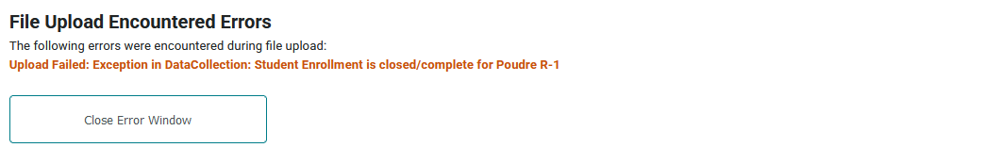
- Invalid Cip/ProgramID: If you enter an invalid Cip Code or ProgramId, you will get an error. The Cde_ID, CIP, and ProgramID must match what is in the Gateway on your current program approval. If you get an error, check to make sure the ProgramID listed is the BASE ID and not the Program INSTANCE ID.

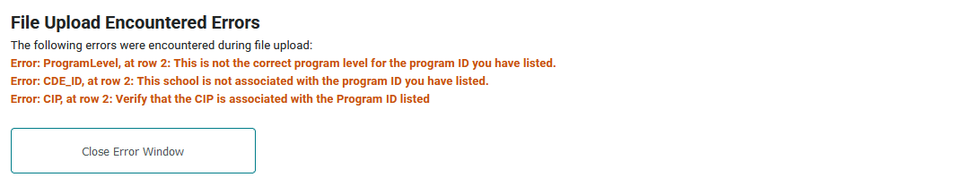
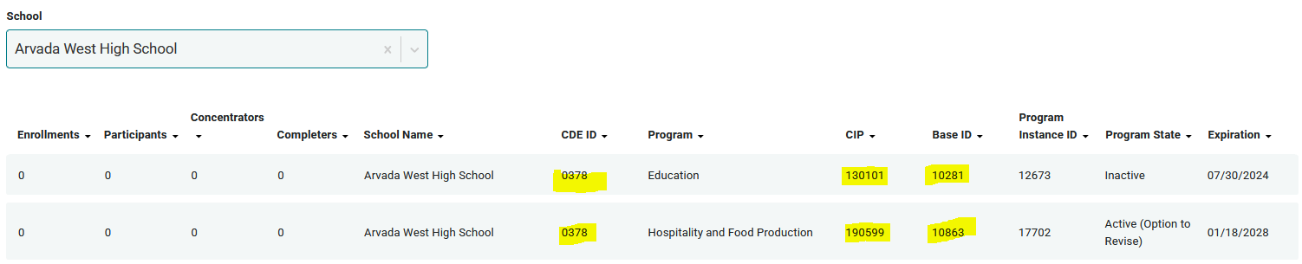

- Invalid Values: If you enter an invalid value or the length doesn’t match what the file layout requires, you will receive an error. The message will also tell you what the valid values are for you to choose from.

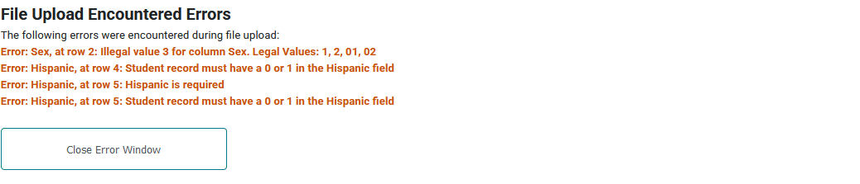
- Hispanic/Race Flag: If you flag a student as Hispanic but don’t indicate at least one other race, you will receive an error. A second race category must be selected for Hispanic students. If you don’t know, select “White”. Also, if you fail to enter the Hispanic flag for a student, or leave all race/ethnicity blank, you will receive an error.

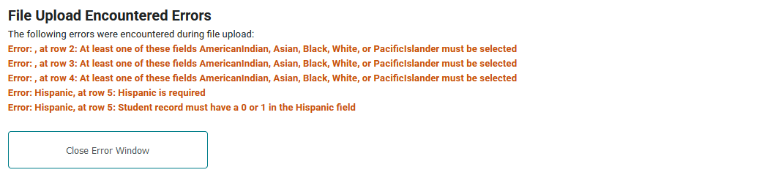

- WBL/WBL Type: If you enter that a student participated in work-based learning but don’t indicate the type, or indicate the type, but don’t flag that the student participated in work-based learning, you will receive an error. (Remember these fields are required as of data year 2024-25)

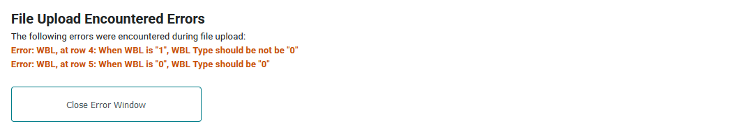

- Participant/Concentrator/Completer: If you flag a student as a completer and fail to also flag the student as a concentrator and participant or flag a student as a concentrator but fail to also flag the student as a participant, you will receive an error. Students who achieve concentrator and/or completer status must be flagged as achieving prior enrollment status (I.E. you can’t be a two-year concentrator without being a one-year participant)

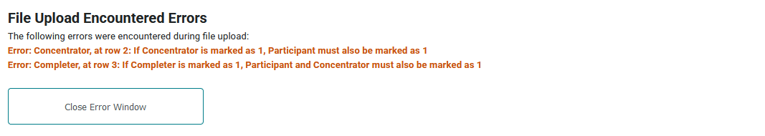

Finalizing Enrollment

- Once you have uploaded your data, you should wait until the next business day to check your data. You may check the numbers by going to the Data Collection/Menu page and simply reviewing the counts of Enrolled, Participant, Concentrator, and Completer there, or you may navigate to Reports, search for ‘Enrollment’, and run the ‘Enrollment Data by Secondary School Report’ for 2025-26.

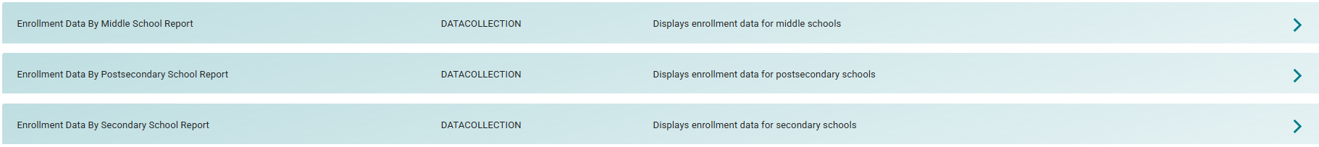

- The Enrollment Status (Final Step) section of the Colorado CTE Gateway (https://coloradoCTE.com) should only be visible to the individual who is assigned the ‘Local DC – Submission Approver’ permission for the district. There should only be one Submission Approver per district. Most of the time, this is the district’s assigned Power User. However, the Power User can delegate this role by assigning the ‘Local DC – Submission Approver’ permission on a user profile. If you need access, reach out to your institution’s primary CTE contact. (AKA “Power User”)
Note: Do not select the complete button and hit SAVE until ALL enrollment for the entire district is complete. Once this button is selected, the data will be locked for editing in the gateway.
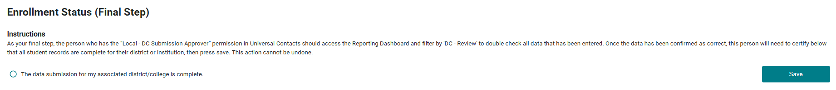

Secondary File Layout
*Required fields will error if blank or if columns are missing or moved*
Column  Header  (Row 1 of your Excel file.  Must match exactly) | Is Data Required or Optional? | Field Coding | Field Length  (Number of characters)
ProgramLevel | Required | The level of the approved program Secondary=1 | 1
SchoolYear | Required | The school year is the last two digits of the spring year of the school year. SchoolYear = 26 for a student in the 2025-2026 school year. | 2
HomeCDE_ID | Required | The 4-digit CDE school code for the student’s primary school of academic enrollment. This may be the same school where the CTE program is approved or it may be a different school.  The next field below, CDE ID, is the school where the CTE program is approved. | 4
CDE_ID | Required | The 4-digit CDE school code, for the school where the CTE program is approved. Every CTE program is officially approved for a specific school.  This school code is shown in your program list on the Data Collection/Enrollment page of ColoradoCTE.com | 4
CIP | Required | 6-digit CIP code. No dots or dashes.  This is shown in your program list on the Enrollment page of ColoradoCTE.com | 6
ProgramID | Required | 5-digit Program Base ID (NOT Program Instance ID)  This is shown in your program list on the Enrollment page of ColoradoCTE.com | 5
SASID | Required | The 10-digit Colorado Department of Education student ID.  Also called the RITS ID, CDE ID or State ID.  This number must be correct and accurate! | 10
FirstName | Required | This should be the same first name that was reported to CDE by the school district. Don’t use apostrophes or hyphens. Two words separated by a space is okay. | 50
MiddleName | Optional | This should be the same middle name that was reported to CDE by the school district. Do not use punctuation such as apostrophes or hyphens. Two or three words separated by spaces are okay. | 50
LastName | Required | This should be the same last name that was reported to CDE by the school district. Do not use punctuation such as apostrophes or hyphens. Two words separated by a space is okay. | 50
DOB | Required | Either MMDDYYYY with no slashes or hyphens (Ex. 09172005) or mm/dd/yyyy format (Ex. 9/17/2005). The format for all dates in the file must be the same. Do not mix formats. | 8-10
Sex | Required | - 01 = Female  - 02 = Male  This should be the same sex as was reported to CDE or the student’s gender at birth. (There is not currently a non-binary option due to federal reporting guidelines) | 2
Grade | Required | - 070 = Grade 7  - 080 = Grade 8  - 090 = Grade 9  - 100 = Grade 10  - 110 = Grade 11  - 120 = Grade 12  - SPU = Special or Ungraded – Does not fit categories above  This should be the same grade level that is reported for the student to CDE. | 3
Phone | Optional | 10 digits, no hyphens or parenthesis. The primary purpose of the phone number is to aid your school during the Follow-up process so that you have a number to contact program concentrators. | 10
Email | Optional | Provide if you wish to use email to contact students for the Follow-up process. | 50
Hispanic | Required | Hispanic or Latino Ethnicity: A person of Cuban, Mexican, Puerto Rican, South or Central American, or other Spanish culture or origin, regardless of race. The term “Spanish origin” can be used in addition to “Hispanic/Latino or Latino.”  - 0 = Non-Hispanic  - 1 = Hispanic  Note: Whether you answer Hispanic or non-Hispanic for this ethnicity field, you must still pick at least one of the following 5 race fields below. If you’re not sure for those who are Hispanic, select White. | 1
AmericanIndian | Required | American Indian or Alaska Native Race: A person having origins in any of the original peoples of North and South America (including Central America), and who maintains a tribal affiliation or community attachment.  - 0 = Not American Indian  - 1 = American Indian | 1
Asian | Required | Asian Race: A person having origins in any of the original peoples of the Far East, Southeast Asia, or the Indian Subcontinent including, for example, Cambodia, China, India, Japan, Korea, Malaysia, Pakistan, the Philippine Islands, Thailand, and Vietnam.  - 0 = Not Asian  - 1 = Asian | 1
Black | Required | Black or African American Race: A person having origins in any of the Black racial groups of Africa.  - 0 = Not Black  - 1 = Black | 1
White | Required | White Race: A person having origins in any of the original peoples of Europe, the Middle East, or North Africa  - 0 = Not Black  - 1 = White | 1
PacificIslander | Required | Native Hawaiian or Other Pacific Islander Race: A person having origins in any of the original peoples of Hawaii, Guam, Samoa, or other Pacific Islands.  - 0 = Not Pacific Islander  - 1 = Pacific Islander | 1
LimitedEnglish | Required | - 0 = Proficient in the English language / unknown  - 1 = Student has limited English proficiency  Student was not born in the United States or whose native language is a language other than English; or is a Native American or Alaska Native and comes from an environment where a language other than English has an impact on language proficiency; or is migratory and whose native language is other than English, and who comes from an environment where a language other than English is dominant; and (2) has sufficient difficulty speaking, reading, writing, or understanding the English language, and whose difficulties may deny such individual the opportunity to learn successfully in classrooms where the language of instruction is English or to participate fully in our society. | 1
IEP | Required | - 0 = Student does not have an active IEP  - 1 = Student has an active IEP | 1
Active504 | Required | - 0 = Student does not have an active 504  - 1 = Student has an active 504 | 1
Disadvantaged | Required | - 0 = Student is not economically disadvantaged and/or student is not eligible for the Free and Reduced Lunch program  - 1=Student is economically disadvantaged and/or student is eligible for the Free and Reduced Lunch program  You must provide a valid answer to this question. If staff at your school or district inform you that they cannot provide Free and Reduced Lunch data, then please refer them to this memorandum. This memo is valid indefinitely. | 1
MigrantStudent | Required | - 0 = Student was not reported to CDE as a migrant student or status is unknown  - 1 = Student was reported to CDE as a migrant student | 1
HighSchoolGraduate | Required | - 0 = Student did not graduate  - 1 = Student did receive a high school diploma this year  - 2 = High School senior did not receive a diploma this year; will be continuing for a 5th year  - 3 = High School senior did not receive a diploma this year; will be continuing for a 6th year | 1
WBL  Program Quality Measure for Perkins V | Required | - 0 = Student has not experienced any of these  - 1 = Student has experienced at least one of these  Student has experienced any of the following Work-based Learning as part of this CTE program:  - Industry sponsored project  - Supervised entrepreneurship experience (e.g., school-based enterprise managed by students)  - Credit-for-work experience  - Clinical experience  - Internship  - Pre-apprenticeship  - Apprenticeship  **Note, CTE WBL requires 30 credit hours of WBL in the program reported. Please report based on the CTE definition and not necessarily what you reported to the CDE. | 1
RegisteredApprenticeship | Required | - 0 = Student did not participate in a Registered Apprenticeship as a part of this program  - 1 = Student did participate in a Registered Apprenticeship as a part of this program  - Error if Blank | 1
SecondaryCert | Required | - 0 = Student did not receive an industry certificate/certification as a part of this program  - 1 = Student received industry certificate(s)/certification(s) that is/are on the LoQC list  - 2 = Student received industry certificate(s)/certification(s) that is/are not on the LoQC list  - 3 =Student received industry certificates/certifications that are both on and not on the LoQC list  - Error if blank  If you aren’t certain whether a credential is on the LoQC, see the List of Qualifying Credentials here: https://ed.cde.state.co.us/postsecondary/the-big-three/industry-recognized-credentials | 1
WBLtype | Required | Indicate what type of Work-based Learning the student has experienced. If a student has experienced multiple kinds of Work-based Learning, select the highest level out of the following experiences that the student had this school year.  - 0 = Student did not experience any work-based learning as part of this program.  - 1 = Student did an industry-sponsored project  - 2 = Student did a supervised entrepreneurship experience (e.g., school-based enterprise managed by students)  - 3 = Student did a credit-for-work experience  - 4 = Student did a clinical experience  - 5 = Student did an internship  - 6 = Student did a pre-apprenticeship  - 7 = Student did an apprenticeship  - Error if blank  **Note, our WBL Type codes may not match the CDE’s WBL Type codes. Please report based on our definitions and not necessarily what you reported to the CDE. | 1
Participant  Definition changed starting in 19/20 academic year per Perkins V | Required | - 0 = Student has not reached participant status this year  - 1 = Student has reached participant status this year (one year)  Participant Status: A participant is a secondary student who has completed one (1) or more Carnegie Units within a CTE program pathway as defined in the program approval documentation. Typically, one Carnegie Unit is the equivalent of one year-long course, so in most cases a student will be a participant after completing one year-long course or two semester-long courses within the program. | 1
Concentrator  Definition changed starting in 19/20 academic year per Perkins V | Required | - 0 = Student has not reached concentrator status this year  - 1 = Student has reached concentrator status this year (two years)  CTE Concentrator Status: A secondary student who has completed two (2) or more Carnegie Units within a CTE program pathway as defined in the program approval documentation. Typically, two Carnegie Units is the equivalent of two year-long courses or 240 hours calculated.  Accumulated credits completed in previous years within the same CTE program should be counted toward the current reporting year.  This field is not limited to a specific grade level.  If you counted a student as a concentrator, you should also count them as a participant.  See the bulleted instructions section above in this document for more explanation about this field. | 1
Completer | Required | - 0 = Student has not reached completer status this year  - 1 = Student has reached completer status this year  Completer Status: A secondary student who has reached the point this reporting year of completing all or 100% of the requirements of at least one pathway sequence as defined in your program approval.  Accumulated credits completed in previous years within the same CTE program should be counted toward the current reporting year.  Consult your CTE program approval paperwork for the credit requirements needed for completer pathways.  This field is not limited to a specific grade level.  A student does not have to graduate high school to be considered a program completer.  If you mark a student as a completer then also mark them as a participant and concentrator.  See the bulleted instructions section above in this document for more explanation about this field. | 1
InstructorID | Optional | First 3 characters of instructor’s last name. Field is used for report sorting for Follow up. Only one teacher per student program allowed. Courses not collected. | 3
NOTE ABOUT CTE GATEWAY FILE TEMPLATE |  | Additional fields are “hidden” in the template if you download it from the website. If you format or expand columns as you work on your file in preparation to upload, make sure to re-hide these additional columns before you upload so that they do not cause an error. Additional columns are not permitted.

End of File Layout

Secondary Enrollment Frequently Asked Questions (FAQ)

Screenshot of Secondary Starter Enrollment file (not all columns are displayed):
- Why are there bold and italics in the column headers in the template I downloaded?
    - Bold fields are required during the upload process.
    - Italic fields are optional but should be reported where available.

- Why is there a little green triangle in the upper left corner of some of the cells in my Excel spreadsheet?
  - The little green triangle (see screenshot above) indicates that the data in the cell is formatted as text data in a numeric field. Excel automatically determines what type of data is in a column by looking at the first few lines of data. If the data is all numbers then Excel assumes that the entire column is numeric. If the first few lines contain dates then Excel assumes that the entire column contains dates. If the first few cells contain non-numeric text then Excel assumes that the entire column contains text data. It is recommended that once you download the template for the year to highlight the entire spreadsheet as text. You can also format the cells as text by preceding the data in the cell with a single apostrophe (‘). If you do this, then the green triangle appears. Note that all cells in a column must be formatted the same for the file to upload correctly which is why it is easiest to format all as text.

- Why do leading zeros disappear in the Excel spreadsheet?
- This is related to the discussion in 2 above. In numeric fields, leading zeros are always removed by Excel. To get the leading zero to appear you have to either format the cell as text or enter a single apostrophe in front of the number in the cell, e.g. enter ’0123 in a cell instead of just 0123. This is another reason we recommend formatting the entire spreadsheet as text after you download it.

- Why does the error report say that various fields have no value found but when I look in the spreadsheet there is a value there?
- This is closely related to the items above. If you, for instance, download the active teacher report in order to add more records to it, the data in the downloaded Excel file will generally be formatted as text. Hence numeric fields such as Program ID will be numbers formatted as text and will appear with the green triangle in the upper left corner of each cell. If you add more records and put numeric data in (no green triangle in the cell, no apostrophe preceding the value in the cell) then the validator cannot read that data. Excel looks at the first few lines, determines that the column contains text and then cannot read the numeric data you added in later rows. This works (or fails to work as the case may be) conversely as well. If you download the starter file there is no data in it. If you put numeric values in the first few rows of data then add rows with text data in the numeric columns, the validator will be unable to read the differently formatted data. The main point of this is that all the fields in any given column must be the same type – either text or numeric which is why we suggest formatting the entire spreadsheet as text.

- Do I have to put leading zeros into fields such as CDE ID and Program ID?
  - It is preferable so that data remains consistent. The data file format above shows leading zeros required in CDE_ID, CIP, and ProgramID. If you are modifying or adding records in a file that already has data in it with leading zeros (see the discussion above) then you must format your new data to match what is already in the file. So if you download the Follow-up Student list and it has, for example, 01122 for program ID, then any rows you add or modify should have the leading zeros or you will get the error described in 5 above. If you are starting with an empty file, then format the entire file and columns as text.

- Why can’t I use a normal date in the DOB field?
  - You can if ALL the dates are normal dates. The validator will accept dates in the format such as 1/5/1993 if all the dates in the column are done the same way. All dates should either be the eight character string such as 03302014, or all should be normal dates such as 3/30/2014.

- Can I remove columns for data we’re not submitting or rearrange the order of columns?
  - No and no. Every column of data must be in the header and in the exact order of the file layout or you will get an error on importing. Don’t change or alter the header or remove or hide columns in any manner. The exception to this is the Follow-up Student List. If you download the list from the Gateway, ALL columns will appear. However, as you can see from the data file format for Follow up, not all of those columns are required for upload. You can simply ignore any columns that are not required, or you can delete them before uploading.

- Can I include duplicate students in my file upload?
  - Yes, if the student is enrolled in multiple programs. You should only include one student record per school and program. If you include a student record twice for the same school and programid, you will get an error message.

- If my program is inactive, can I still report enrollment?
  - Yes, beginning in AY 2024-25, the Gateway should allow you to report enrollment and follow up for any program that was active at some point between July 1, 2025 and June 30, 2026. Should you encounter an error, please submit a ticket to CTE@CCCS.edu

- If I had students that were taught by both credentialed and non-credentialed instructors, can I report all of them for enrollment?
  - It depends. In general, you can only report enrollment for those students taught by credentialed instructors. However, if you have a credentialed instructor for any part of the year, and the rest of the year is completed by a substitute who is not yet credentialed, you may report enrollment for the entire year.

- If I added a student by accident, will a new file upload with the student removed also remove the student from the Gateway?
  - No. If you add a student manually or to your file upload in error, simply removing them from the file and reuploading will NOT remove them from the Gateway. To remove a student, you must go into the program and delete the student manually as shown below.

End of FAQs

