Postsecondary CTE Enrollment Reporting 2025-26

Postsecondary Level CTE Student Enrollment Reporting for:

Aims Community College (AIMS)

Colorado Mountain College (CMC)

Colorado Department of Corrections (DOC)

CMU-Technical (CMU)

Emily Griffith Technical College (EGTC)

Pickens Technical College (PTC)

Technical College of the Rockies (TCR)

Submission Deadline: August 31, 2026
The institutions listed in the box above must use this specific file format to report their postsecondary level CTE student data to CCCS. CCCS will then populate the statewide CTE data system for the areas of CTE accountability reporting and funding purposes. Do not use a previous year file format document to report student data. File format documents are updated every year and the requirements may be different than the previous year’s version.

Contents (Ctrl + click on a title to go to that section in this document)
General Information
File Instructions
Steps for Capturing Completers (Academic and CTE)
Steps for Capturing Non-Completers (Academic and CTE)
File Layout
Postsecondary Enrollment Frequently Asked Questions (FAQ)

General Information

What is CTE Enrollment reporting?
CTE enrollment data contains demographic and programmatic information for secondary and postsecondary level career and technical education (CTE) students. There are two principal components of reporting on CTE students, which are the “Enrollment” and “Follow-up” files. Because of its ties to continued federal and state funding for CTE programs, it is critical that the data be timely, valid, complete, and reliable. All CTE data submitted to CCCS is subject to audits internally, by the state, and by multiple federal agencies

How is CTE student data used and why is it required?
- Perkins Formula Allocation Grants – CTE student enrollment data is used in a portion of the formula, which calculates the distribution of federal Perkins funds to secondary and postsecondary institutions. Perkins formula allocations are reported to the schools by CCCS in the spring of each year.
- Federal Performance Reports – CTE student information is used for the federal performance report (Perkins performance metrics) due in December of each year to the US Department of Education and also dispersed to local recipients each spring to address in their Perkins local plans. This report uses information on special populations, gender, ethnicity, and program participation, concentration, and completion information.
- Colorado Technical Act - The secondary CTE data is used to generate the Colorado Technical Act (CTA) report, which is required by the state legislature each year. This report contains information on CTE programs including enrollment, completion, placement, costs, FTE, and other items.
- Program Approval & Renewal Process - The CTE student data populates three separate 5-year trend reports used by CCCS to evaluate new and existing CTE programs as set forth by the State Board for Community Colleges and Occupational Education (SBCCOE).
- Civil Rights Compliance Audits - The CCCS internal audit department uses the CTE student information to determine which schools should be visited in a compliance visit as mandated by the U.S. Department of Education, Office for Civil Rights. Selection can include such factors as concentrations of special populations, region, size, and time of the last visit.
- Other CCCS Reports - Many other reports are produced internally throughout the year for CCCS staff in order to maintain as well as continually improve and promote CTE in the state of Colorado.

CTE Student Enrollment
The CTE student enrollment submission for most postsecondary institutions is created in late summer following the close of each academic year. The process involves collecting demographic and program participation, concentration, and completion status for students taking CTE courses.

CTE Student Follow-up
The CTE student follow-up data is due March 31st of each year. The follow-up process involves the gathering of placement information on students who completed a CTE program in the previous year.

What is the privacy policy of CTE student records at CCCS?
Aggregated data reports derived from CTE student records are considered to be public information with most reports mandated as such by the federal Perkins Act. Individual student records are protected in accordance with the Family Education Rights & Privacy Act (FERPA) and other established policies.

File Instructions
Please read all the instructions and file layout below carefully before starting your file. Don’t just build your file based on only the table layout. It is likely to save you time, limit frustration, and help to ensure that your data is complete and accurate in the long run.
- You should only report data for postsecondary level programs in this file. Use the most current guidance and template to create a data file of students to report to CCCS for the purpose of completing required accountability reporting for your postsecondary level CTE programs for the 2025-2026 academic year. The correct Excel template and Guidance can be found in the Gateway under Menu/Data Collection/Enrollment.

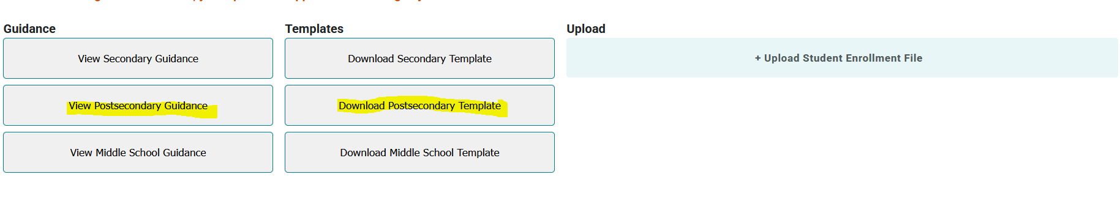
- You must use the current CCCS (not CDHE) assigned CTE CIP code and five-digit program Base ID (not Instance ID) for your post-secondary level CTE programs. The up-to-date CIP codes and program base IDs are listed in Gateway under Data Collection/Enrollment. Depending on the timing of your file submission, this may be different from your internal source data and what is on record at DHE. It is an ongoing process to keep CIP codes in sync between DHE and our CTE data system. Invalid CIP codes and program IDs will result in errors during validation.
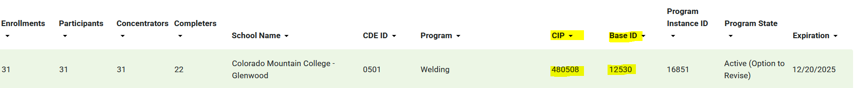

- Both part-time and full-time students enrolled in CTE should be included in your file, even though part-time students are excluded from most CTE data reports. CCCS includes part-time students for FTE but doesn’t include the completion and placement rate for part-time students since the success rate is generally much lower. Separating them into full and part time accomplishes this goal. Federal reports separate students into these two categories for some of the same reasons. Part-time students are also not included in the federal allocation formula as technical colleges don’t report on part-time students by individual student.
Note: part-time and full-time CTE status does not use the same criteria as academic part-time and full-time status. See the layout for FTE definition.
- Your institution does not have to use the exact same steps we’ve outlined when assembling your records, but you do need to end up with correct data according to all of the rules outlined in this document. The data that you report is tied to strict federal mandates and federal funding and is subject to CCCS state level and federal level monitoring visits and audits. The rules in these instructions must be followed by all participating institutions in order to ensure equitable student counts and comparisons for all.
- Use Excel to assemble your student file following the file layout guidelines below. Note that the header names and order must match the student file layout as indicated or it will not upload into the Colorado CTE Gateway. Once you have assembled your file, you will use the upload and validation utility built into the Data Collection/Enrollment section to process your file. Please direct your questions to cte@cccs.edu.

Records to Include in Your File
In order to determine the CTE student population, calculate the Perkins performance metrics, and calculate the Perkins formula allocations, your file will need to contain records on the following types of students. Your institution may not have all the listed types of students, but if they are present, then you should include them:
- CTE Major Completers
- CTE Major Non-completers
- CTE Major Participants
- Academic Major Participants
- Undeclared Major Participants
- AGS Major Full-Time CTE

The following is a walkthrough on how you can go about capturing these records followed by the file format layout.

Steps for Capturing Completers (Academic and CTE)
You will first need to capture records of all students who earned a Certificate or Associate’s level degree during the 25-26 academic year (Summer 2025, Fall 2025, and Spring 2026) and then narrow those down to one record per student per CIP (both academic and CTE).

Example
Greg Brown earned 3 awards during the academic year. He earned 2 certificates in CIP (major) 520201 and one AS degree which is CIP 240199. He should get two records in the Excel file, one for 520201 and one for 240199 even though he received 3 awards. You will have the opportunity to mark his record with the number of certificates or degrees earned per CIP (academic or CTE).

In the past, CCCS used the SURDS full year Degrees Awarded files for Aims, CMC, and CMU-Tech to get these records. Colleges are encouraged to follow the same process because completers should be verifiable in the institution’s IPEDS submission for the same academic year. In other words, for completers, do not submit records for students who did not officially receive a certificate or degree in the academic year. Area technical colleges should use the same data sources they use to submit for IPEDS if they do that. For institutions that do not submit for IPEDS, then use what makes sense at your institution. It should be something that you can back up with student records in case of an audit.
Once you have narrowed down the completer records in your Excel file to one record per student per CIP, then perform the following steps:

Where the award in the record is a CTE certificate or degree (determined by CIP):
- Mark the Completer field with a “1”. By doing this, you will then have flagged all CTE completers in your file.
  - Mark the Full-Time CTE, Participant, and Concentrator fields with “1”. Students who received a CTE certificate or degree are considered to be Full-Time CTE, participants, and concentrators within the CTE CIP they received the award in, and they will all go into CTE enrollment as long as there is a CCCS approved CTE program to match.
  - Make sure the CIP CTE field is populated with the current CTE CIP code approved by CCCS.
  - Fill in the Program (base) ID with the current CTE Program ID.
  - Some colleges may offer an AGS/CTE type of award within a CTE program. If your college has this type of program completer, then make sure the CTE CIP field is populated with the CTE program CIP code and not 240102. The AGS/CTE award is currently a rare situation, and it must be written into the CTE program approval documentation. Do NOT mark students who received a standard AGS degree of 240102 with a CTE CIP code.
  - Fill in all other fields in each record.

Where the award in the record is an ACADEMIC certificate or degree (CIP determined):
  - Leave the Completer field blank because these are not CTE completer records.
  - Leave the Concentrator field blank.
  - Mark the Participant field with a “1” if the student completed at least one (1) CTE course in the CTE program within the reporting year. (The definition of Participant changed per the Perkins V definition versus years prior to 2020)
  - If this is a an academic AGS record, mark the Full-Time CTE field with a “1” if the student met the definition for Full-Time CTE enrollment as described in the next section on Steps for Capturing non-completers (Academic and CTE).
  - Make sure the CIP Academic field is populated with the academic CIP (either 240101, 240102, or 240199 or other CIP that is not a CTE program at your institution). Leave the Program ID field blank.
  - Place a “1” in the new AGS/Academic field if the student received an AGS/Academic award (240102).
  - Fill in all other fields in each record.

Steps for Capturing Non-Completers (Academic and CTE)
The next step is to add student records to the Excel file where there were no certificates or degrees awarded (neither academic nor CTE) in the academic year. This process is much more complex than capturing completers.
In the past, CCCS used the SURDS Term Enrollment files for Aims, CMC, and CMU-Tech to get these records. The colleges are encouraged to follow the same process because enrollment should be verifiable in the institution’s IPEDS submission for the same academic year. Area technical colleges should also use the same data sources they use to submit for IPEDS if they do that. For institutions that do not submit for IPEDS, then use what makes sense at your institution.

- Calculating Full-Time CTE Enrollment: In a temporary dataset, capture one record per student from the three SURDS term enrollment files and calculate the total CTE (vocational) credit hours per term divided by the number of terms attended. You will also need to use the SURDS course files to get CTE credit hours. In addition, you must capture the declared major of the last term attended. You should end up with just one record per student in your dataset with this process. You will then need to calculate Full-Time CTE enrollment for all these non-completer records (both academic and CTE).

Example:
Paula Smith was enrolled in the summer, fall, and spring semesters of the 25-26 academic year, but she was not eligible to receive a program certificate or degree for the year.
Paula declared her major as 520201 (Business Administration) for the summer semester, her major as 520302 (Accounting) for the fall semester, and her major as 520201 (Business Administration) for the spring semester. Business Administration and Accounting are both CTE approved programs at Paula’s institution.
Paula’s SURDS Term Enrollment Records Show:
Term | Major (CIP) | Total CTE Credit Hours
2025 (Summer) | 520201 | 2
2025 (Fall) | 520302 | 8
2026 (Spring) | 520201 | 12

An average of the CTE credit hours is calculated for all three terms that she attended (if she had attended only 2 terms then divide by 2). If the average is 6 or greater hours per the number of terms attended, the student is considered Full-Time CTE. Paula’s average CTE credit hours for the year: (2+8+12) / 3 = 7.3 CTE credit hours. Her declared major for the last term attended was 520201 which is a CTE CIP.

Important Note: It does not matter if the major codes are academic or CTE; you still need to determine Full-Time CTE enrollment status for all the non-completer records. So, even if the major code of the last term attended for Paula was 240101, she would still make the Full-Time CTE status. The record would not go into the CTE enrollment because the last term attended is academic, but the record could be used for other Perkins reporting purposes. An example of this would be AGS students that are also Full-Time CTE used in the Perkins Formula Allocations. You will also need to perform the Full-Time CTE calculation for the academic AGS completers and flag their records too. (See above section on Steps for Capturing Completers (Academic and CTE).
.
Note: At this point you can add the records from this dataset to your Excel file and complete the following steps but be aware that you should make the following changes to ONLY your non-completer dataset, not to the completer records you already added

- For each non-completer record, enter the CIP (major) of the last term attended. Enter academic CIP codes into the CIP Academic field and CTE CIP codes into the CIP CTE field. If the CIP is undeclared for the last term attended, then enter 999999 into the CIP Academic field. You should not have any blank CIP fields in your file.
- If the CIP is that of an approved CTE program, populate the Program ID field for the record.
- Leave the Program ID field blank for academic and undeclared CIP codes. Program (base) ID is for CTE CIP codes only.
- Some colleges may offer an AGS/CTE type of award within a CTE program. If your college has this type of program, then make sure the CTE CIP field is populated with the CTE program CIP code and not 240102. The AGS/CTE award is currently a rare situation, and it must be written into the CTE program approval documentation. Do not mark students pursuing a standard AGS major of 240102 with a CTE CIP code.
- For ALL records (completers and non-completers and academic), mark the Full-Time CTE field with a “1” in records where you calculated the average CTE credit hours of 6 or greater. If the average is less than 6, then leave the Full-Time CTE field blank.

For all non-completer records that you DID mark as Full-Time CTE:
- Mark Participant with a “1” because non-completer students who are Full-Time CTE are also considered to be Participants. However, they are not considered to also be Concentrators automatically. Mark Concentrator with a “1” only if the student meets the following threshold as defined in Perkins V: The student is Full-Time CTE AND the declared major of the last term attended is a CTE CIP AND the student either, a) earned at least twelve (12) CTE credits within the single CTE program or b) completed such a program if the program is twelve (12) or fewer credits.

For all non-completer records that you did NOT mark as Full-Time CTE:
- Mark them as a Participant ONLY IF they have completed more than one CTE course, per the Perkins V participant definition. You do NOT need to calculate concentration for students you did NOT mark as Full-Time CTE.

Final Steps:
- Back up your data at this time.
- Review your non-completer records. You may now exclude any non-completer records from your Excel file where Full-Time CTE, Concentrator, and Participant are ALL blank within a single record. The CIP can be either CTE, academic, or undeclared or other non CTE. These are students who don’t need to be counted in any accountability reporting or funding formula.
- The last non-completer step if you haven’t already done so is to fill in all required fields for each remaining record in your Excel file.
- Important note for Aims and CMC - you should end up with some AGS completer and non-completer records marked as Full-Time CTE and participant plus some marked as just participants. If you do not, then contact CCCS and we’ll explore why those are not showing up in your dataset. This is very important for the Perkins Formula Allocations.

Finalizing your Excel File
- To finalize your Excel file, make sure that you clean out any duplicate records for a single student where they are listed with the same CTE CIP or ACADEMIC CIP code. This can happen if you accidentally added multiple completer records or different awards within a single CIP, or if you have one completer record and one non-completer record. You should keep the completer record in this case.

- Make sure all columns conform to the file format guidance below and that all required fields, **including social security numbers if your college plans to participate in the Perkins grant** are complete. It is also a best practice before uploading the file to have some records checked and the file reviewed internally.
- Once you have finalized your file, you are ready to upload it to the Data Collection>Enrollment section of ColoradoCTE.com. Use the upload file button to import files. Do not email or mail your data file(s) to CCCS! Once your file is uploaded, it will be imported into the CTE data system and you will then be able to review the results within 24 hours. You’ll have the opportunity to update the data (up to the August 31 deadline) with another file version if you find that you need to amend records. Note that updating records is only possible if your entity has not “certified” its records are complete and accurate in the Gateway. Do NOT certify your submission as complete until all records have been uploaded and checked for accuracy!
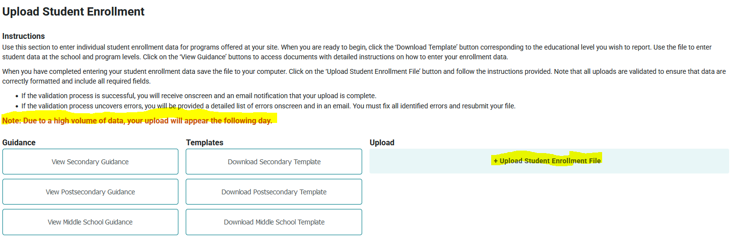
- When you upload a file you will see an onscreen error log of the first 10 errors in the file, as well as receive an email with the list of errors. Your file will not be accepted for import until all errors are corrected.
- A note about deleting students: If you add a student manually or to your file upload in error, simply removing them from the file and reuploading will NOT remove them from the Gateway. To remove a student, you must go into the program and delete the student manually as shown below.
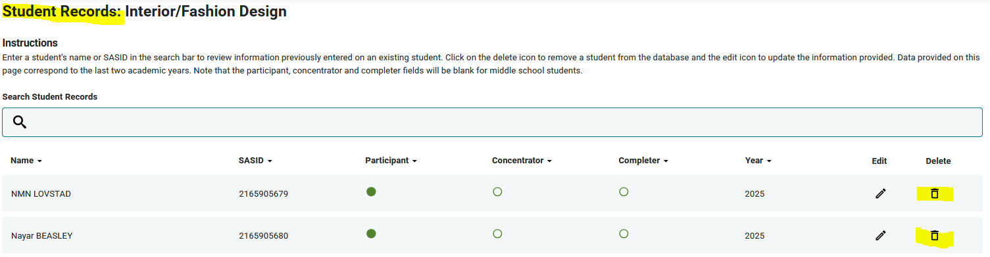
- A note about INACTIVE programs. Beginning in AY 2024-25, the Gateway should allow you to report enrollment and follow up for any program that was active at some point between July 1, 2025, and June 30, 2026. Should you encounter an error, please submit a ticket to CTE@CCCS.edu
- There are no specific requirements for the filename but it is suggested that you name the file in such a way that it can be clearly distinguished from any other files that you upload, e.g. <schoolname>_<year>.xls
- Access to the Data Collection section of the Colorado CTE Gateway (https://coloradoCTE.com) is granted by the district’s primary CTE contact by assigning the ‘DC – Student Record’ permission on a user profile. If you need access, reach out to your institution’s primary CTE contact.

Common Errors and How to Fix Them
- Exception in Data Collection: This error typically means the data year in your file upload is invalid. Check to make sure the data year is the last two digits of the current year enrollment. (For example, 2025-26 = Data Year 26)

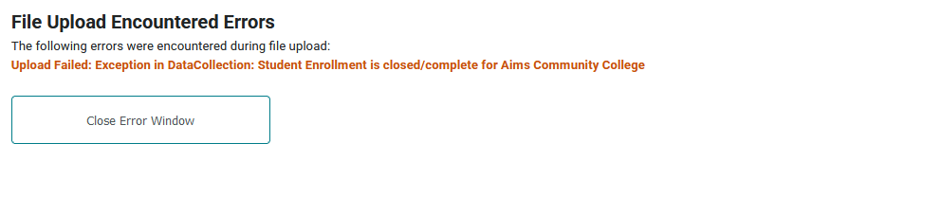
- Invalid Cip/ProgramID: If you enter an invalid Cip Code or ProgramId, you will get an error. The Cde_ID, CIP, and ProgramID must match what is in the Gateway on your current program approval. If you get an error, check to make sure the ProgramID listed is the BASE ID and not the Program INSTANCE ID.
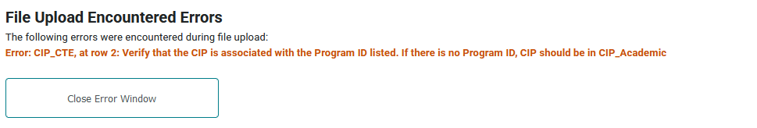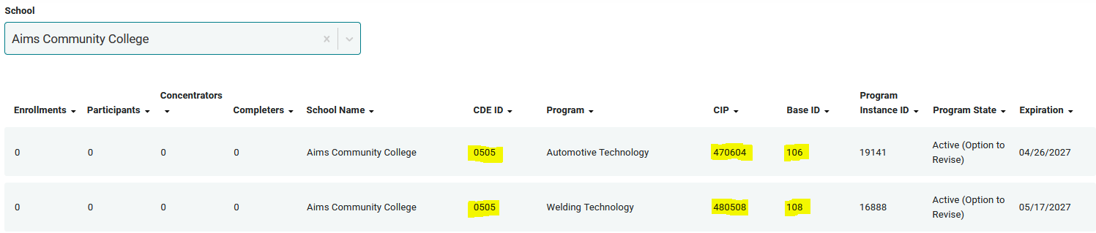

- Invalid Values: If you enter an invalid value or the length doesn’t match what the file layout requires, you will receive an error. The message will also tell you what the valid values are for you to choose from.
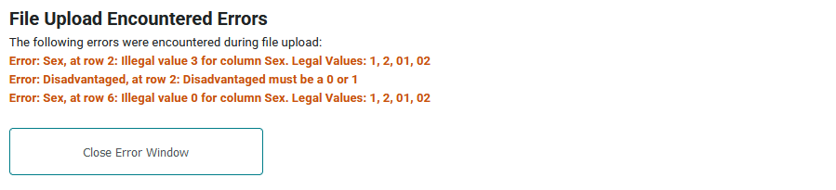
- Completer/Certificate/Degree Mismatch: If you flag a student as a Completer but don’t indicate at least one Certificate or Degree received, or you enter at least one Certificate or Degree received but don’t indicate the students as a completer, you will get an error.
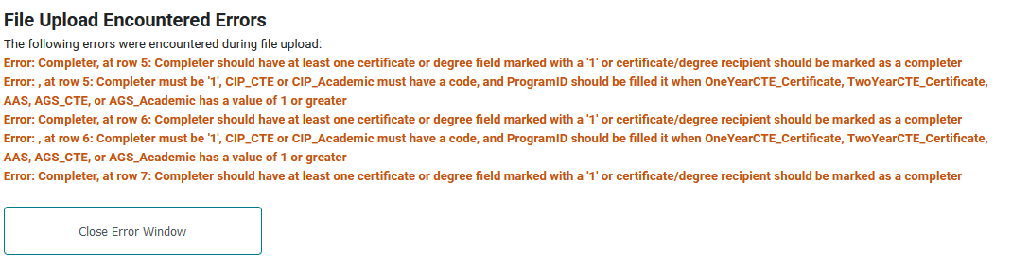

- Registered Apprenticeship: If you don’t flag whether a student participated in a Registered Apprenticeship, you will receive an error. (Remember this field is required as of data year 2024-25)

- Participant/Concentrator/Completer: If you flag a student as a completer and fail to also flag the student as a concentrator and participant or flag a student as a concentrator but fail to also flag the student as a participant, you will receive an error. Students who achieve concentrator and/or completer status must be flagged as achieving prior enrollment status (I.E. you can’t be a two-year concentrator without being a one-year participant)
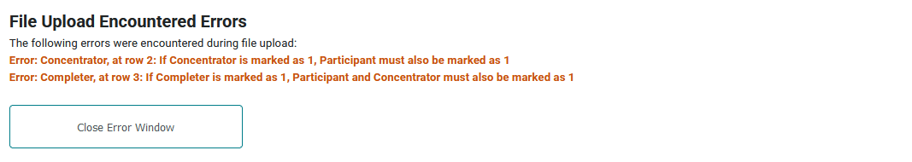

Post-Secondary File Layout
Your final file version should contain only one record per student per CIP.
Is Data Required or  Optional? | Column Header (Row 1 of your Excel file must match exactly) | Description | Values | Field Length (Number of characters)
Required | ProgramLevel | This is the level of the CTE approved program. This file layout will only allow postsecondary level records.  This field serves as an important identifier of the level of these records. | Postsecondary level = 2  Error if blank or not 2. | 1
Required | SchoolYear | The school year is the last two digits of the spring year of the school year. For year 26 Enrollment terms that would be included in the 2025-2026 school year include Summer 2025, Fall 2025, and Spring 2026.  This field serves as an important identifier of the AY of these records. | Enter the 2-digit year = 26  Error if blank or not correct for the current reporting year. | 2
Required | InstitutionID | The unique 4-character code designated to each Colorado postsecondary institution. See codes listed in the column to the right. For most institutions, this code is the same as the code you report to CDHE. | Enter the 4-digit code for your institution:  - 6326 = Technical College of the Rockies  - 0000 = DOC  - 5124 = Emily Griffith Technical College  - 6109 = Pickens Technical College  - 0505 = Aims Community College  - 0501 = Colorado Mountain College  - 0518 = CMU Tech  Error if blank or invalid. | 4
Required | CIP_CTE | The CTE 6-digit CIP code – “Classification of Instructional Program”.  If you don't know the CIP ID of an approved CTE program, it is on the Data Collection>Enrollment page of ColoradoCTE.com. | Enter the 6-digit approved CTE code; no extra characters such as dots or dashes.  Completers: enter the CIP for the CTE award.  Non-completers: enter the CIP (declared major) from the last term attended (see the calculating Full-Time CTE in the instructions).  Error if invalid or is an academic CIP or if blank and CIP Academic field is also blank. | 6
Required | CIP_Academic | The academic 6-digit CIP code – “Classification of Instructional Program”.  This would be CIP codes that are not for CCCS, CTE approved programs.  District colleges-For non-completer students whose last term enrolled was undeclared, fill in this field with 999999.  If the student received an academic award, then enter that academic CIP.  If the student did not receive an academic award but was pursuing an academic path, enter the academic CIP (declared major) from the last term attended (see the calculating Full-Time CTE in the instructions). | Enter the 6-digit non-CTE code or undeclared code of 999999; no extra characters such as dots or dashes.  Error if invalid or is a CTE CIP (except for non-approved CTE programs) or if blank and CIP CTE field is also blank.  TCR, DOC, Pickens, and Emily Griffith: this field should be blank for all of your records because all programs at your institutions are CTE. | 6
Required | ProgramID | The up to 5-digit Program (Base) ID of the CTE approved program. This unique identifier is assigned during CCCS program approval process and follows the program throughout its existence. (This is not the same as the 4 or 5 digit Program Request ID. This is also not the Program Instance ID)  If you don't know the program ID of the approval, they are located on the Data Collection>Enrollment page of ColoradoCTE.com  This field is required in order to match a student up to the correct CTE programs at your institution. | Enter the code; no extra characters such as dots or dashes.  Leave blank if CIP ID field is academic: 240101 (AA), 240102 (AGS), or 240199 (AS), other non CTE CIP, or undeclared-999999.  Completers: enter the program ID for the award.  Non-completers: enter the program id that matches the declared major (CIP) from the last term attended.  Error if invalid. Error if CIP CTE field is blank. | 5
Required | SSN | The student's official social security number.  CCCS uses the SSN to determine students who receive Pell or State aid as part of the Perkins formula allocation. If SSN is left blank, then those students cannot be identified as receiving Pell or State Aid and will not be used in that criteria of the Perkins formula allocation. If your entity plans to participate in Perkins, it is your responsibility to provide this information as part of the enrollment file. We understand that some students do not disclose an SSN to the institution and are not eligible for financial aid. | Enter the numeric, 9-digit SSN with no dashes.  Leave blank only if SSN was not reported by student. Note that if you leave all SSNs blank your entity will NOT receive Perkins funds the following year as that data is critical to the formula process.  Error will be generated if SSN entered is invalid. | 9
Required | Student  Identification  Number | The official number that uniquely identifies a student at an Institution up to nine characters. This is not the SSN. It is your internal institution identifier and will be used as the main identifier in our CTE data system.  - Pickens prefix a "P" to the left of your 8 digit internal ID or use 9-digit value.  - Emily Griffith prefix "EGO" plus the 6 digit internal ID or “EG” plus the 7 digit internal ID.  - TCR use your internal id –supposed to be the first 2 letters of the last name followed by a 7 digit numeric code.  - DOC prefix “DOC” to the left of your 6 digit numeric internal identifier. If identifier is less than 6 digits, then pad with leading zeros.  - District colleges should use the internal identifier that you would report in your SURDS submissions. | Enter the 9-digit value.  Error if blank. | 9
Optional, but encouraged | SASID | SASID is the "State Assigned Student Identification Number". The 10-digit Colorado Department of Education student ID. Also sometimes called the State ID, CDE ID or RITS ID.  CCCS would like to have this ID in order to track the successes of all CTE students across secondary and postsecondary levels. | Enter the 10-digit numeric value.  Error if SASID is invalid (according to CDE rules). | 10
Required | FirstName | First Name of student. | Enter the first name. Two words separated by a space is okay. Special characters such as apostrophes, dashes, or spaces in sequence are not allowed.  Error if blank. | 50
Optional | MiddleName | Middle name of student. | Two or three words separated by spaces are okay. No apostrophes or periods. Contiguous spaces and hyphens are not allowed. Single initial okay. | 50
Required | LastName | Last name of student. | Enter the last name. Special characters such as apostrophes, dashes, or spaces in sequence are not allowed.  Error if blank. | 50
Required | DOB | The date of birth as designated on the individual's legal birth registration or certificate. | Enter either MMDDYYYY with no slashes or hyphens (Ex. 09171992) or mm/dd/yyyy format (Ex. 9/17/1992). The format for all dates in the file must be the same. Do not mix formats. Error if blank or mixed formatting. | 8-10
Required | Sex | Gender of the student.  Gender is required for CTE federal accountability reports. At this time, the federal guidance still requires that we report based on only a binary option for gender. If unknown, then use the DHE rule where students having a Student Identification Number that ends with an even digit report as male; students having a Student Identification Number that ends with an odd number report as female. This field is specifically needed to determine nontraditional status of program enrollment under Perkins V. | - 1 = Male  - 2 = Female  Error if blank.  Note that these values are opposite the values in the secondary level file format. | 2
Required | Grade | This field is used to identify the student grade level for the academic year. | - 13 = 0-44 Quarter Hours or 0-29 semester hours successfully completed  - 14 = greater than 44 quarter hours or greater than 29 semester hours successfully completed | 2
Optional | Phone | Phone number of student. Provide if you wish to contact students by phone during the CTE Follow-up process. Needed only for CTE completers. | Enter 10 digits, no hyphens. | 10
Optional | Email | Email address of student. Provide if you wish to use email to contact students for the CTE Follow-up process. Needed only for CTE completers. | Enter up to 50 character email.  Error if invalid general email format (i.e. missing @ symbol or period before domain name). | 50
Required | Hispanic | A flag that indicates whether a student specified this ethnicity as describing themselves to the school.  A person of Cuban, Mexican, Puerto Rican, South or Central American, or other Spanish culture or origin, regardless of race. The term “Spanish origin” can be used in addition to “Hispanic/Latino or Latino.”  This is a required special population field under Perkins V and your institution must develop a process for reporting this data. You are required to report this data if students have self-reported it to your institution. | - 1 = yes  - 0 = no (student did not self-identify  Error if blank. | 1
Required | AmericanIndian | A flag that indicates whether a student specified this race as describing themselves to the school.  A person having origins in any of the original peoples of North and South America (including Central America), and who maintains a tribal affiliation or community attachment.  This is a required special population field under Perkins V and your institution must develop a process for reporting this data. You are required to report this data if students have self-reported it to your institution. | - 1 = yes  - 0 = no (student did not self-identify  Error if blank. | 1
Required | Asian | A flag that indicates whether a student specified this race as describing themselves to the school.  A person having origins in any of the original peoples of the Far East, Southeast Asia, or the Indian Subcontinent including, for example, Cambodia, China, India, Japan, Korea, Malaysia, Pakistan, the Philippine Islands, Thailand, and Vietnam.  This is a required special population field under Perkins V and your institution must develop a process for reporting this data. You are required to report this data if students have self-reported it to your institution. | - 1 = yes  - 0 = no (student did not self-identify)  Error if blank. | 1
Required | Black | A flag that indicates whether a student specified this race as describing themselves to the school.  A person having origins in any of the Black racial groups of Africa.  This is a required special population field under Perkins V and your institution must develop a process for reporting this data. You are required to report this data if students have self-reported it to your institution. | - 1 = yes  - 0 = no (student did not self-identify)  Error if blank. | 1
Required | White | A flag that indicates whether a student specified this race as describing themselves to the school.  A person having origins in any of the original peoples of Europe, the Middle East, or North Africa.  This is a required special population field under Perkins V and your institution must develop a process for reporting this data. You are required to report this data if students have self-reported it to your institution. | - 1 = yes  - 0 = no (student did not self-identify)  Error if blank. | 1
Required | PacificIslander | A flag that indicates whether a student specified this race as describing themselves to the school.  A person having origins in any of the original peoples of Hawaii, Guam, Samoa, or other Pacific Islands.  This is a required special population field under Perkins V and your institution must develop a process for reporting this data. You are required to report this data if students have self-reported it to your institution. | - 1 = yes  - 0 = no (student did not self-identify)  Error if blank. | 1
Required | LimitedEnglish | This field is used to determine if a student does not speak and understand the English language in an instructional setting well enough to benefit from the instruction and complete the objectives of the program without special assistance.  Federal definition:  A student who has limited ability in speaking, reading, writing, or understanding the English language, and  - whose native language is a language other than English, or  - who lives in a family or community environment in which a language other than English is the dominant language.  Mark students as limited English if they have taken an ESL course during the academic year. If your institution does not offer ESL courses to English language learners, then you may use an alternate resource such as a self-report question on the institution application, but report for the current academic year only. This is a required special population field under Perkins V and your institution must develop a process for reporting this data. | - 1 = Student is limited English proficient  - 0 = Student is not limited English proficient  Error if blank. | 1
Required | Disability | This field is used to determine if a student has a disability as categorized under ADA or Section 504 of the Rehabilitation Act.  The student could have self-reported a disability to the institution or have sought special services at the institution. This is a required special population field under Perkins V and your institution must develop a process for reporting this data. | - 1 = Student has a disability  - 0 = Student does not have a disability  Error if blank. | 1
Required | Disadvantaged | This field is used to determine if a student is a Pell recipient during the academic year.  This is a required special population field under Perkins V and your institution must develop a process for reporting this data. | - 1 = Student is economically disadvantaged  - 0 = Student is not economically disadvantaged  Error if blank. | 1
Required | OutOfWorkforce  Individual  (Formerly known as Displaced Homemaker) | An out-of-workforce individual is someone who is unemployed or underemployed and is experiencing difficulty in obtaining or upgrading employment AND has one or more of the following scenarios:  - Has been working primarily in the home without being paid (such as a stay at home parent or caretaker of family member) and has fewer marketable skills  - Has been working unpaid in the home (such as a stay at home parent or caretaker of family member) and has been dependent on the income of another family member but is no longer supported by that income  - Is the dependent spouse of a member of the Armed Forces on active duty and the family income is significantly reduced due to deployment, permanent change of station, or service-related death or disability  - Is a parent whose youngest dependent child will become ineligible to receive Social Security Assistance.  Usually self-reported to institution on student application. This is a required special population field under Perkins V and your institution must develop a process for reporting this data. | - 1 = Student is an Out-of-Workforce Individual  - 0 = Student is not an Out-of-Workforce Individual  Error if blank. | 1
Required | SingleParent | Federal definition: Single parents, including single pregnant women.  Usually self-reported to institution on student application. This is a required special population field under Perkins V and your institution must develop a process for reporting this data. | - 1 = Student is a single parent  - 0 = Student is not a single parent  Error if blank. | 1
Optional, but encouraged | ColoradoResident | Residency of student determined by tuition classification.  CCCS would like to have this information in order to track the successes of all CTE students across secondary and postsecondary levels. | - 1 = Colorado resident  - 2 = not a Colorado resident  - Blank = Unknown | 1
Optional, but encouraged | MilitaryStatus | This field is used to determine if a student is a veteran and if so, whether he or she receives veteran's benefits.  CCCS would like to have this information in order to track the successes of all CTE students across secondary and postsecondary levels. | - 1 = Student is a veteran, receives veteran's benefits, but is not on active duty  - 2 = Student is on active duty in the military  - 3 = Student is a veteran but does not receive veteran's benefits  - Blank = not applicable | 1
Optional, but encouraged | EducationPlan | This field is used to determine if a student is pursuing a certificate, an associate degree, or is upgrading skills.  CCCS would like to have this information in order to track the successes of all CTE students across secondary and postsecondary levels. | - 1 = Student is pursuing a certificate  - 2 = Student is pursuing an associate degree  - 3 = Student is upgrading skills  - Blank = not applicable | 1
Required | Participant  (New Perkins V definition starting 19/20 academic year) | This field is used to identify all students who have completed at least one (1) CTE course within any CTE program area (defined by CIP code) within the reporting year. | - 1 = Student is a participant  - 0 = Student is not a participant  Error if blank.  - CIP can be academic or undeclared for either answer. | 1
Required | Concentrator  (New Perkins V definition starting 19/20 academic year) | This field is used to identify those students who are Full-Time CTE and meet the CTE Concentrator definition. This field is required under Perkins V in order to calculate the Perkins performance metrics.  Only mark students as concentrators if the student, within the reporting year, has:  earned at least twelve (12) CTE credits within a single CTE program (defined by CIP code), or  completed such a program if the program is twelve (12) or fewer credits. | - 1 = Student is a concentrator  - 0 = Student is not a concentrator  Error if blank.  - Error if marked with a 1 and Full-Time CTE is blank and CIP CTE is blank or invalid. | 1
Required | Completer | This field is used to identify those students who have completed the minimum CTE credit hours required within a single CTE program area (defined by CIP code) for a CTE certificate or degree. This field is needed under Perkins V in order to calculate the Perkins performance metrics.  Data entered in this field should be verifiable in the institution’s IPEDS submission for the same academic year. A student is only a completer if they received a CTE award (certificate or degree) on your IPEDS submission within the same academic year. | - 1 = Student is a CTE completer  - 0 = Student is not a CTE completer  Error if blank.  - Error if marked with a 1 and all certificate or degree total count fields below are blank.  - Error if marked with a 1 and CIP CTE is blank or invalid. | 1
Required | FullTimeCTE | This field is used to identify those students meeting the CTE full-time definition of taking 6 or greater CTE (vocational) credits averaged over the number of terms attended in the reporting year. This field is required under Perkins V in order to determine the CTE student population used in calculating the Perkins performance metrics and in calculating the Perkins formula allocations.  This is not the same as the part-time or Full-Time general attendance at your institution. You must use the calculation described in the instructions to determine this value.  Students who are not full-time CTE will not be listed in the CTE enrollment. Students who are full-time CTE but do not have a valid CTE program ID and CTE CIP (major) in their record will not be listed in the CTE enrollment.  Important note for AIMS and CMC - you should end up with some AGS completer and non-completer records marked as Full-time CTE and participant plus some marked as just participants. If you do not, then contact CCCS and we’ll explore why those are not showing up in your dataset. This is very important for the Perkins Formula Allocations. | - 1 = Student is full-time CTE  - 0 = Student is not full-time CTE  Error if blank.  CIP can be academic or undeclared for either answer. | 1
Required | OneYearCTE_  Certificate | This field identifies the number of one-year CTE certificates awarded to this student this academic year in just this program CIP. Must be verifiable in the institution’s IPEDS submission for the same academic year. | Enter total number of CTE one-year certificates awarded to this student under just this program CIP during the academic year.  Error if Full-time CTE, Completer, CIP CTE and Program ID fields are blank. | 1
Required | TwoYearCTE_  Certificate | This field identifies the number of two-year CTE certificates awarded to this student this academic year in just this program CIP. Must be verifiable in the institution’s IPEDS submission for the same academic year. | Enter total number of CTE two-year certificates awarded to this student under just this program CIP during the academic year.  Error if Full-time CTE, Completer, CIP CTE and Program ID fields are blank. | 1
Required | AAS | This field identifies the number of AAS degree awards to this student this academic year in just this program CIP. Must be verifiable in the institution’s IPEDS submission for the same academic year. | Enter total number of AAS degrees awarded to this student under just this program CIP during the academic year.  Error if Full-time CTE, Completer, CIP CTE and Program ID fields are blank. | 1
Required | RegisteredApprenticeship | This field identifies whether a student participated in a registered apprenticeship as part of the program. | 0 = Student did not participate in a Registered Apprenticeship as a part of this program  1 = Student did participate in a Registered Apprenticeship as a part of this program Error if blank. | 1
Required | AGS_CTE | This field identifies the number of AGS/CTE degree awards to this student this academic year. Must be verifiable in the institution’s IPEDS submission for the same academic year. Can be identified by a combination of major and minor codes.  CTE/AGS degree options must be documented and approved within an institution’s program approval to be counted in the VE-135. This field is not to be used for general academic AGS degrees. | Enter total number of AGS/CTE degrees awarded to this student under just this program CIP during the academic year.  Error if Full-time CTE, Completer, CIP CTE and Program ID fields are blank. | 1
Required | AGS_Academic | This field identifies the number of AGS degree awards to this student this academic year in just this AGS academic CIP. Must be verifiable in the institution’s IPEDS submission for the same academic year.  Important note for AIMS and CMC—you should end up with some AGS completer and non-completer records marked as Full-time CTE and participant plus some marked as just participants. If you do not, then contact CCCS and we’ll explore why those are not showing up in your dataset. This is very important for the Perkins Formula Allocations. | Enter total number of AGS academic degrees awarded to this student under just this academic CIP during the academic year.  Error if CIP Academic field is blank. | 1
End of File Layout

Postsecondary Enrollment Frequently Asked Questions (FAQ)

Screenshot of Postsecondary Starter Enrollment file (not all columns are displayed):

- Why are there bold and italics in the column headers in the template I downloaded?
    - Bold fields are required during the upload process.
    - Italic fields are optional but should be reported where available. **Note that SSN appears as an optional field, but it is critical that SSN be provided for students that have one in order to support the data matching required to do the Perkins V formula calculation.**

- Why is there a little green triangle in the upper left corner of some of the cells in my Excel spreadsheet?
  - The little green triangle (see screenshot above) indicates that the data in the cell is formatted as text data in a numeric field. Excel automatically determines what type of data is in a column by looking at the first few lines of data. If the data is all numbers then Excel assumes that the entire column is numeric. If the first few lines contain dates then Excel assumes that the entire column contains dates. If the first few cells contain non-numeric text then Excel assumes that the entire column contains text data. It is recommended that once you download the template for the year to highlight the entire spreadsheet as text. You can also format the cells as text by preceding the data in the cell with a single apostrophe (‘). If you do this, then the green triangle appears. Note that all cells in a column must be formatted the same for the file to upload correctly which is why it is easiest to format all as text.

- Why do leading zeros disappear in the Excel spreadsheet?
- This is related to the discussion in 2 above. In numeric fields, leading zeros are always removed by Excel. To get the leading zero to appear you have to either format the cell as text or enter a single apostrophe in front of the number in the cell, e.g. enter ’0123 in a cell instead of just 0123. This is another reason we recommend formatting the entire spreadsheet as text after you download it.

- Why does the error report say that various fields have no value found but when I look in the spreadsheet there is a value there?
- This is closely related to the items above. If you, for instance, download the active teacher report in order to add more records to it, the data in the downloaded Excel file will generally be formatted as text. Hence numeric fields such as Program ID will be numbers formatted as text and will appear with the green triangle in the upper left corner of each cell. If you add more records and put numeric data in (no green triangle in the cell, no apostrophe preceding the value in the cell) then the validator cannot read that data. Excel looks at the first few lines, determines that the column contains text and then cannot read the numeric data you added in later rows. This works (or fails to work as the case may be) conversely as well. If you download the starter file there is no data in it. If you put numeric values in the first few rows of data then add rows with text data in the numeric columns, the validator will be unable to read the differently formatted data. The main point of this is that all the fields in any given column must be the same type – either text or numeric which is why we suggest formatting the entire spreadsheet as text.

- Do I have to put leading zeros into fields such as CDE ID and Program ID?
  - It is preferable so that data remains consistent. The data file format above shows leading zeros required in CDE_ID, CIP, and ProgramID. If you are modifying or adding records in a file that already has data in it with leading zeros (see the discussion above) then you must format your new data to match what is already in the file. So if you download the Follow-up Student list and it has, for example, 01122 for program ID, then any rows you add or modify should have the leading zeros or you will get the error described in 5 above. If you are starting with an empty file, then format the entire file and columns as text.

- Why can’t I use a normal date in the DOB field?
  - You can if ALL the dates are normal dates. The validator will accept dates in the format such as 1/5/1993 if all the dates in the column are done the same way. All dates should either be the eight character string such as 03302014, or all should be normal dates such as 3/30/2014.

- Can I remove columns for data we’re not submitting or rearrange the order of columns?
  - No and no. Every column of data must be in the header and in the exact order of the file layout or you will get an error on importing. Don’t change or alter the header or remove or hide columns in any manner. The exception to this is the Follow-up Student List. If you download the list from the Gateway, ALL columns will appear. However, as you can see from the data file format for Follow up, not all of those columns are required for upload. You can simply ignore any columns that are not required, or you can delete them before uploading.

- Can I include duplicate students in my file upload?
  - Yes, if the student is enrolled in multiple programs. You should only include one student record per school and program. If you include a student record twice for the same school and programid, you will get an error message.

- If my program is inactive, can I still report enrollment?
  - Yes, beginning in AY 2024-25, the Gateway should allow you to report enrollment and follow up for any program that was active at some point between July 1, 2025 and June 30, 2026. Should you encounter an error, please submit a ticket to CTE@CCCS.edu

- If I had students that were taught by both credentialed and non-credentialed instructors, can I report all of them for enrollment?
  - No. You can only report enrollment for those students taught by credentialed instructors.

- If I added a student by accident, will a new file upload with the student removed also remove the student from the Gateway?
  - No. If you add a student manually or to your file upload in error, simply removing them from the file and reuploading will NOT remove them from the Gateway. To remove a student, you must go into the program and delete the student manually as shown below.

End of FAQs

