Middle CTE Enrollment Reporting 2025-26
Submission Deadline: July 31, 2026
This file format is only for CTE programs approved for middle school level students. Do not use it to report students in secondary school or postsecondary level CTE programs. Instead, use the “Secondary” data file format for 7th and 8th grade students who are enrolled in secondary level CTE programs at high schools and postsecondary schools. Please contact CCCS if you are unsure about the difference between CTE program approval levels and which students to report within them.

Contents (Ctrl + click on a title to go to that section in this document)
Middle School Enrollment Instructions
Middle School Enrollment File Format
Middle School Enrollment FAQ

General Information

What is CTE Enrollment reporting?
CTE enrollment data contains demographic and programmatic information for secondary and postsecondary level career and technical education (CTE) students. There are two principal components of reporting on CTE students, which are the “Enrollment” and “Follow-up” files. Because of its ties to continued federal and state funding for CTE programs, it is critical that the data be timely, valid, complete, and reliable. All CTE data submitted to CCCS is subject to audits internally, by the state, and by multiple federal agencies.

How is CTE student data used and why is it required?
- Perkins Formula Allocation Grants – CTE student enrollment data is used in a portion of the formula, which calculates the distribution of federal Perkins funds to secondary and postsecondary institutions. Perkins formula allocations are reported to the schools by CCCS in the spring of each year.
- Federal Performance Reports – CTE student information is used for the federal performance report (Perkins performance metrics) due in December of each year to the US Department of Education and also dispersed to local recipients each spring to address in their Perkins local plans. This report uses information on special populations, gender, ethnicity, and program participation, concentration, and completion information.

- Colorado Technical Act - The secondary CTE data is used to generate the Colorado Technical Act (CTA) report, which is required by the state legislature each year. This report contains information on CTE programs including enrollment, completion, placement, costs, FTE, and other items.
- Program Approval & Renewal Process - The CTE student data populates three separate 5-year trend reports used by CCCS to evaluate new and existing CTE programs as set forth by the State Board for Community Colleges and Occupational Education (SBCCOE).
- Civil Rights Compliance Audits - The CCCS internal audit department uses the CTE student information to determine which schools should be visited in a compliance visit as mandated by the U.S. Department of Education, Office for Civil Rights. Selection can include such factors as concentrations of special populations, region, size, and time of the last visit.
- Other CCCS Reports - Many other reports are produced internally throughout the year for CCCS staff in order to maintain as well as continually improve and promote CTE in the state of Colorado.

CTE Student Enrollment
The CTE student enrollment submission for most secondary institutions is created in early summer following the close of each academic year. The process involves collecting demographic and program participation, concentration, and completion status for students taking CTE courses. The due date for secondary enrollment is July 31st of each year.

CTE Student Follow-up
The CTE student follow-up data is due March 31st of each year. The follow-up process involves the gathering of placement information on students who concentrated or completed a CTE program in the previous year. (Note that this does not apply to middle school programs)

What is the privacy policy of CTE student records at CCCS?
Aggregated data reports derived from CTE student records are considered to be public information with most reports mandated as such by the federal Perkins Act. Individual student records are protected in accordance with the Family Education Rights & Privacy Act (FERPA) and other established policies.

File Instructions
Please read all the instructions and file layout below carefully before starting your file. It is likely to save you time, limit frustration, and help to ensure that your data is complete and accurate in the long run.
- You should only report data for middle school level programs in this file. Use the most current guidance and template to create a data file of students to report to CCCS for the purpose of completing required accountability reporting for your secondary level CTE programs for the 2025-2026 academic year. The correct Excel template and Guidance can be found in the Gateway under Menu/Data Collection/Enrollment.

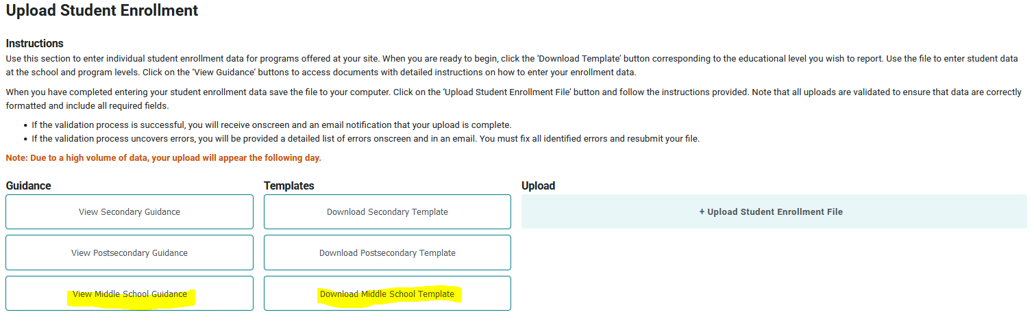

- You must use the current CCCS (not CDHE) assigned CTE CIP code and five-digit program Base ID (not Instance ID) for your middle school level CTE programs. The up-to-date CIP codes and program base IDs are listed in Gateway under Data Collection/Enrollment. Invalid CIP codes and program IDs will result in errors during validation.

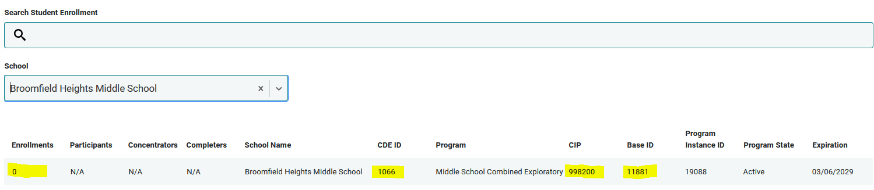

- Note that unlike Secondary or Post Secondary, for Middle School reporting, no demographic information is collected beyond gender. Therefore, you do not need to be concerned about reporting that information. You should report the same gender you report to the CDE. (Note that there is no current code for non-binary. For students who report as non-binary, please use the gender at birth.)
- Student Names: You should use the same first name, middle name, last name, and date of birth in this enrollment file that you report to CDE. This will greatly facilitate the mandated data matching processes mentioned above. Note that there should be no punctuation included in the data such as hyphens or apostrophes. These can cause mismatches with the CDE.
- SASID is Mandatory. The state assigned SASID/RITS ID is required for ALL middle school student enrollment records. This is the unique 10-digit ID number that CDE assigns to every K-12 student when they enter the Colorado public education system. You can find a student's SASID by first contacting your district office. Every public school district in Colorado has a SASID contact person. If for some reason, you still cannot locate this contact person for your district, then you may contact CDE staff in Data Services at 303-866-6612.
- Use Excel to assemble your student file following the file layout guidelines below. Note that the header names and order must match the student file layout as indicated or it will not upload into the Colorado CTE Gateway. Once you have assembled your file, you can either upload the completed spreadsheet or use the manual entry method on the website. We recommend the manual entry method if there are fewer students to report; otherwise, we recommend the file upload.

Records to Include in Your File
You should report only one record per student per program per school. Thus, if John Smith was enrolled in a Middle School Agriculture and Combined Exploratory at Lincoln Middle School, then you should provide 2 total records in your enrollment submission--one record for each of the programs he was enrolled in with its distinct CIP and Program ID. You cannot report students in the enrollment file by course. If your file has multiple records for a student in the same CIP and Program ID at the same school, you will receive errors during the validation process and will have to remove those extra records.
Student records that you should include in your middle school enrollment file should meet the following criteria:
- They were enrolled in a middle school level CTE program during the 25-26 school year and completed the program. All enrolled students should be included in your student file.
- The coursework was taught by an appropriately credentialed instructor. If the student took courses taught within a single CTE program by a mix of credentialed and non-credentialed instructors, you can only count those taken by credentialed instructors.

Final Check on your Excel File
- Make sure that you clean out any duplicate records for a single student where they are listed with the same CTE CIP code. This can happen if you accidentally added records by course and didn’t roll up the credits into one program line. There should only be one record for each student per program.
- Make sure all columns conform to the file format guidance below and that all required fields are complete. It is also a best practice before uploading the file to have some records checked and the file reviewed internally.

Uploading and Validating Your Data
- Once you have finalized your file, you are ready to upload it to the Data Collection>Enrollment section of ColoradoCTE.com. Use the upload file button to import files. Do not email or mail your data file(s) to CCCS! Once your file is uploaded, it will be imported into the CTE data system and you will be able to review the results within 24 hours. You’ll have the opportunity to update the data (up to the July 31 deadline) with another file if you find that you need to amend records. Note that updating records is only possible if your entity has not “certified” its records are complete and accurate in the Gateway. Do NOT certify your submission as complete until all records have been uploaded and checked for accuracy!
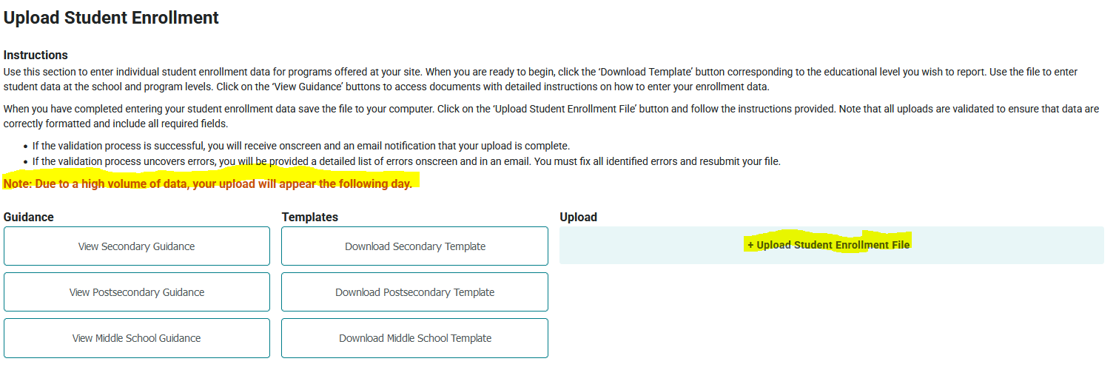
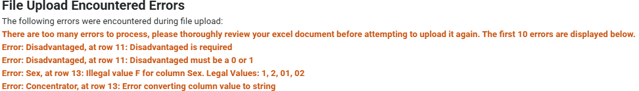
- When you upload a file, you will see an onscreen error log of the first 10 errors in the file, as well as receive an email with the list of errors. Your file will not be accepted for import until all errors are corrected.

- A note about deleting students: If you add a student manually or to your file upload in error, simply removing them from the file and reuploading will NOT remove them from the Gateway. To remove a student, you must go into the program and delete the student manually as shown below.

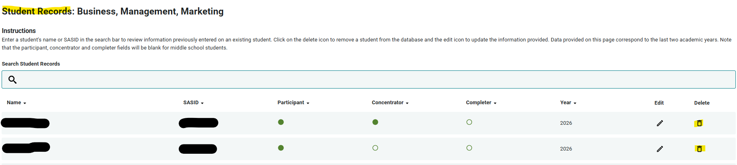

- A note about INACTIVE programs. The Gateway should allow you to report enrollment and follow up for any program that was active at some point between July 1, 2025, and June 30, 2026. Should you encounter an error, please submit a ticket to CTE@CCCS.edu
- There are no specific requirements for the filename, but it is suggested that you name the file in such a way that it can be clearly distinguished from any other files that you upload, e.g. <schoolname>_<year>.xls
- Access to the Data Collection section of the Colorado CTE Gateway (https://coloradoCTE.com) is granted by the district’s primary CTE contact by assigning the ‘DC – Student Record’ permission on a user profile. If you need access, reach out to your institution’s primary CTE contact. (AKA “Power User”)

Common Errors and How to Fix Them
- Exception in Data Collection: This error typically means the data year in your file upload is invalid. Check to make sure the data year is the last two digits of the current year enrollment. (For example, 2025-26 = Data Year 26)
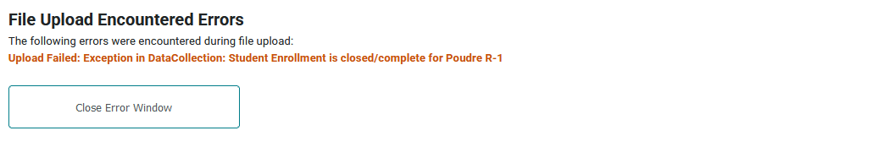
- Invalid Cip/ProgramID: If you enter an invalid Cip Code or ProgramId, you will get an error. The Cde_ID, CIP, and ProgramID must match what is in the Gateway on your current program approval. If you get an error, check to make sure the ProgramID listed is the BASE ID and not the Program INSTANCE ID.
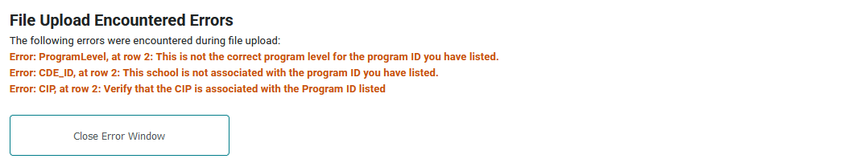
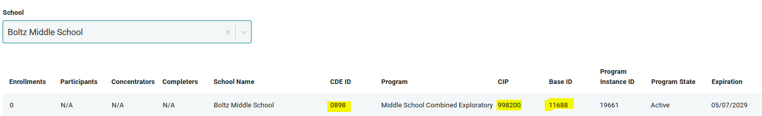

- Invalid Values: If you enter an invalid value or the length doesn’t match what the file layout requires, you will receive an error. The message will also tell you what the valid values are for you to choose from.
- Duplicate Students/Different Schools: If you have a student that transferred from one school to another within the same district, and you enter that student for each school, you may encounter a duplicate student error. This happens because the Gateway sometimes sees the duplicate CIP at two different schools and doesn’t recognize the different CDE ID and/or ProgramID. If you encounter such an error, the workaround is to remove one of the duplicate students and upload it separately or enter the student manually.

Finalizing Enrollment

- Once you have uploaded your data, you should wait until the next business day to check your data. You may check the numbers by going to the Data Collection/Menu page and simply reviewing the counts of Enrolled, Participant, Concentrator, and Completer there, or you may navigate to Reports, search for ‘Enrollment’, and run the ‘Enrollment Data by Secondary School Report’ for 2025-26.

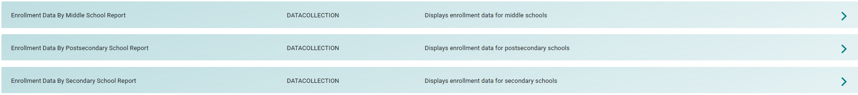

- The Enrollment Status (Final Step) section of the Colorado CTE Gateway (https://coloradoCTE.com) should only be visible to the individual who is assigned the ‘Local DC – Submission Approver’ permission for the district. There should only be one Submission Approver per district. Most of the time, this is the district’s assigned Power User. However, the Power User can delegate this role by assigning the ‘Local DC – Submission Approver’ permission on a user profile. If you need access, reach out to your institution’s primary CTE contact. (AKA “Power User”)
Note: Do not select the complete button and hit SAVE until ALL enrollment for the entire district is complete. Once this button is selected, the data will be locked for editing in the gateway. 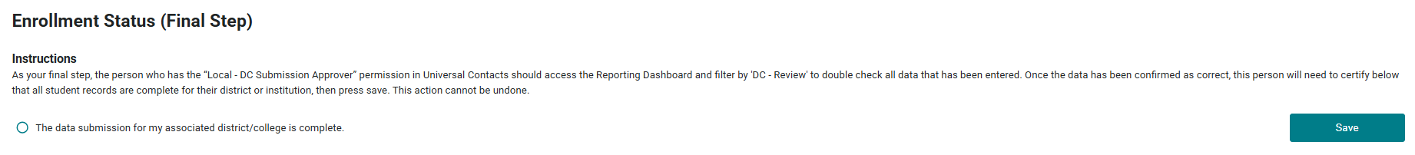

Middle School Enrollment File Layout
Column  Header  (Row 1 of your Excel file  must match exactly) | Is Data Required or Optional? |  | Field Length  (Number of characters)
ProgramLevel | Required | The level of the approved program  Middle School = 5 | 1
SchoolYear | Required | The school year is the last two digits of the spring year of the school year. SchoolYear = 26 for a student in the 2025-2026 school year. | 2
HomeCDE_ID | Required | The 4-digit CDE school code for the student’s primary school of academic enrollment. This may be the same school where the CTE program is approved or it may be a different school.  The next field below, CDE ID, is the school where the CTE program is approved. | 4
CDE_ID | Required | The 4-digit CDE school code, for the school where the CTE program is approved. Every CTE program is officially approved for a specific school.  This school code is shown in your program list on the Data Collection/Enrollment page of ColoradoCTE.com | 4
CIP | Required | 6-digit CIP code. No dots or dashes.  This is shown in your program list on the Enrollment page of ColoradoCTE.com. | 6
ProgramID | Required | 5-digit Program Base ID (NOT Program Instance ID)  This is shown in your program list on the Enrollment page of ColoradoCTE.com | 5
SASID | Required | The 10-digit Colorado Department of Education student ID.  Also called the RITS ID, CDE ID or State ID.  This number must be correct and accurate! | 10
FirstName | Required | This should be the same first name that was reported to CDE by the school district. Don’t use apostrophes or hyphens. Two words separated by a space is okay. | 50
MiddleName | Optional | This should be the same middle name that was reported to CDE by the school district. Don’t use apostrophes or hyphens. Two words separated by a space is okay. | 50
LastName | Required | This should be the same middle name that was reported to CDE by the school district. Don’t use apostrophes or hyphens. Two words separated by a space is okay. | 50
DOB | Required | Either MMDDYYYY with no slashes or hyphens (Ex. 09172005) or mm/dd/yyyy format (Ex. 9/17/2005). The format for all dates in the file must be the same. Do not mix formats. | 8 - 10
Sex | Required | - 01 = Female  - 02 = Male  This should be the same sex as was reported to CDE or the student’s gender at birth. (There is not currently a non-binary option due to federal reporting guidelines) | 2
Grade | Required | - 60 = Grade 6  - 70 = Grade 7  - 80 = Grade 8  This should be the same grade level that is reported for the student to CDE. | 2

End of File Format

Middle School Enrollment Frequently Asked Questions (FAQ)

Screenshot of Middle School Starter Enrollment file (not all columns are displayed):
- Why are there bold and italics in the column headers in the template I downloaded?
    - Bold fields are required during the upload process.
    - Italic fields are optional but should be reported where available.

- Why is there a little green triangle in the upper left corner of some of the cells in my Excel spreadsheet?
  - The little green triangle (see screenshot above) indicates that the data in the cell is formatted as text data in a numeric field. Excel automatically determines what type of data is in a column by looking at the first few lines of data. If the data is all numbers then Excel assumes that the entire column is numeric. If the first few lines contain dates then Excel assumes that the entire column contains dates. If the first few cells contain non-numeric text then Excel assumes that the entire column contains text data. It is recommended that once you download the template for the year to highlight the entire spreadsheet as text. You can also format the cells as text by preceding the data in the cell with a single apostrophe (‘). If you do this, then the green triangle appears. Note that all cells in a column must be formatted the same for the file to upload correctly which is why it is easiest to format all as text.

- Why do leading zeros disappear in the Excel spreadsheet?
- This is related to the discussion in 2 above. In numeric fields, leading zeros are always removed by Excel. To get the leading zero to appear you have to either format the cell as text or enter a single apostrophe in front of the number in the cell, e.g. enter ’0123 in a cell instead of just 0123. This is another reason we recommend formatting the entire spreadsheet as text after you download it.

- Why does the error report say that various fields have no value found but when I look in the spreadsheet there is a value there?
- This is closely related to the items above. If you, for instance, download the active teacher report in order to add more records to it, the data in the downloaded Excel file will generally be formatted as text. Hence numeric fields such as Program ID will be numbers formatted as text and will appear with the green triangle in the upper left corner of each cell. If you add more records and put numeric data in (no green triangle in the cell, no apostrophe preceding the value in the cell) then the validator cannot read that data. Excel looks at the first few lines, determines that the column contains text and then cannot read the numeric data you added in later rows. This works (or fails to work as the case may be) conversely as well. If you download the starter file there is no data in it. If you put numeric values in the first few rows of data then add rows with text data in the numeric columns, the validator will be unable to read the differently formatted data. The main point of this is that all the fields in any given column must be the same type – either text or numeric which is why we suggest formatting the entire spreadsheet as text.

- Do I have to put leading zeros into fields such as CDE ID and Program ID?
  - It is preferable so that data remains consistent. The data file format above shows leading zeros required in CDE_ID, CIP, and ProgramID. If you are modifying or adding records in a file that already has data in it with leading zeros (see the discussion above) then you must format your new data to match what is already in the file. So if you download the Follow-up Student list and it has, for example, 01122 for program ID, then any rows you add or modify should have the leading zeros or you will get the error described in 5 above. If you are starting with an empty file, then format the entire file and columns as text.

- Why can’t I use a normal date in the DOB field?
  - You can if ALL the dates are normal dates. The validator will accept dates in the format such as 1/5/1993 if all the dates in the column are done the same way. All dates should either be the eight character string such as 03302014, or all should be normal dates such as 3/30/2014.

- Can I remove columns for data we’re not submitting or rearrange the order of columns?
  - No and no. Every column of data must be in the header and in the exact order of the file layout or you will get an error on importing. Don’t change or alter the header or remove or hide columns in any manner. The exception to this is the Follow-up Student List. If you download the list from the Gateway, ALL columns will appear. However, as you can see from the data file format for Follow up, not all of those columns are required for upload. You can simply ignore any columns that are not required, or you can delete them before uploading.

- Can I include duplicate students in my file upload?
  - Yes, if the student is enrolled in multiple programs. You should only include one student record per school and program. If you include a student record twice for the same school and programid, you will get an error message.

- If my program is inactive, can I still report enrollment?
  - Yes, beginning in AY 2024-25, the Gateway should allow you to report enrollment and follow up for any program that was active at some point between July 1, 2025 and June 30, 2026. Should you encounter an error, please submit a ticket to CTE@CCCS.edu

- If I had students that were taught by both credentialed and non-credentialed instructors, can I report all of them for enrollment?
  - No. You can only report enrollment for those students taught by credentialed instructors. However, if you have a credentialed instructor for any part of the year, and the rest of the year is completed by a substitute who is not yet credentialed, you may report enrollment for the entire year.

- If I added a student by accident, will a new file upload with the student removed also remove the student from the Gateway?
  - No. If you add a student manually or to your file upload in error, simply removing them from the file and reuploading will NOT remove them from the Gateway. To remove a student, you must go into the program and delete the student manually as shown below.

End of FAQs

