Active Teacher Reporting 2025-26
Submission Deadline: August 31, 2026

Contents (Ctrl + click on a title to go to that section in this document)
Active Teacher Instructions
Active Teacher File Format
Active Teacher Frequently Asked Questions (FAQ)

General Information

What is Active Teachers reporting?
Active Teachers reporting contains credentialing and demographic information for full and part time teachers who teach career and technical education (CTE) students. Under Perkins V, all approved CTE programs must be taught by a credentialed CTE instructor to receive funding. Active teacher records must be submitted by August 31, 2026. It’s extremely important that you meet the deadline, particularly if you will be submitting for CTA reimbursement. (Note: Postsecondary programs no longer need to submit emails of instructor lists to cte@cccs.edu so long as they maintain their instructor lists in Active Teachers)

File Instructions
Please read all the instructions and file layout below carefully before starting your file. Don’t just build your file based on only the table layout. It is likely to save you time, limit frustration, and help to ensure that your data is complete and accurate in the long run.
- You should only report CTE credentialed teachers who taught middle, secondary, or post-secondary programs for the 2025-26 year in this file. Use the most current guidance and template to create a data file of teachers to report to CCCS. The correct Excel template and Guidance can be found in the Gateway under Menu/Data Collection/Active Teachers.
- Permissions to access this part of the site are determined by your district/institution’s primary CTE contact (power user) by assigning the permission ‘DC – Teacher Record.’ If you believe you should have access, contact your district/institution’s primary CTE contact.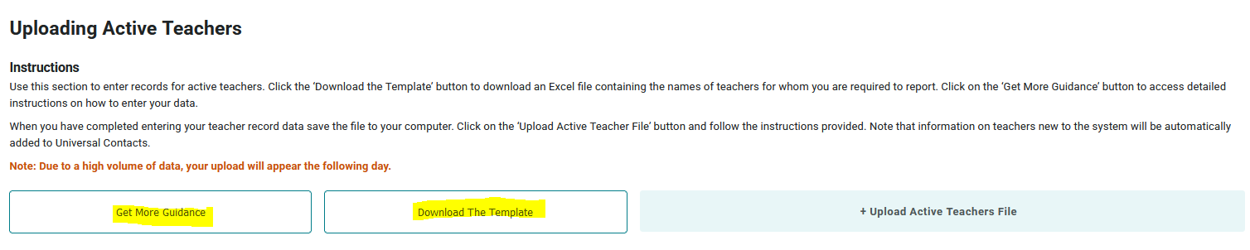
- Only include records of properly credentialed instructors during the year. You may include records for non-credentialed instructors if you fully expect that they will receive official credential approval from CDE before June 30, 2026. To be considered a CTE credentialed teacher, a teacher can obtain their credential AT ANY POINT during the AY from July 1, 2025 – June 30, 2026. If an instructor taught a CTE class during the 2025-26 year, but didn’t receive their credential until June, 2026, they could still be included for 2025-26. If your instructors are not credentialed by June 30, 2026, then your programs are out of compliance, and you must remove the teacher records from the list before June 30th.
- You may include duplicate teachers if they taught multiple programs or at different schools within the district. There should be only one line per school and programid.

Recommended Step Active Teachers
- Update new and existing teachers for your district in Universal Contacts before updating the Active Teachers section under Data/Active Teachers. Only the district/institution power user can do this, but this step will make affiliating Active Teachers to the correct programs much smoother.
- Ensure that credential numbers, areas, and expiration dates are accurate, the teacher toggle is on, and the district and school information is included.
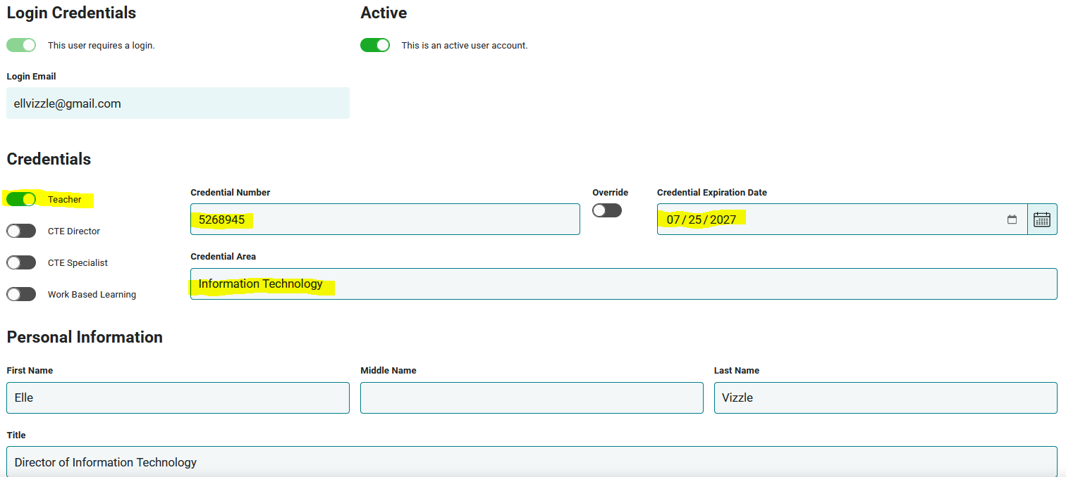
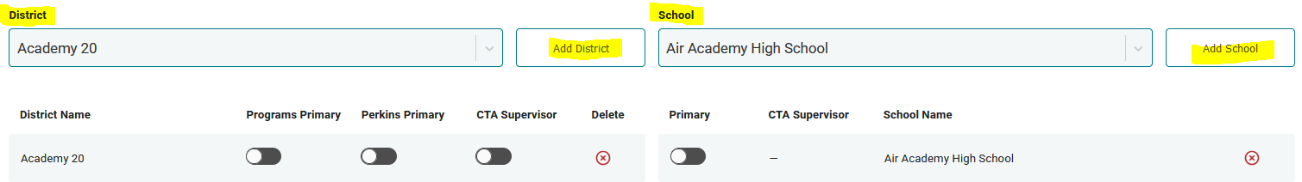
- For name and/or email changes, please email CTE@CCCS.edu for instructions before making changes to any existing contact account. It’s important we do not create duplicates in the Gateway.

- You can add teachers to your district/institution’s list for the current academic year by spreadsheet upload or by individual record entry. If you do not have a lot of teachers to add, we recommend adding them individually on the Data Collection/Active Teachers page. If you have several Active Teachers to report, we recommend using the spreadsheet upload.
- For manual updating, once you have all the contacts updated in Universal Contacts, go to Menu/Data Collection/Active Teachers to affiliate your new active teachers. You may do this by selecting them from the search field on that page. Once entered, their contact information will pop up for editing. To affiliate them with the program they taught, select the school and program and mark whether they were full-time or part-time. (Note: if the teacher is only part-time CTE but a full-time teacher, select full-time here. CTA will calculate the correct portion of CTE time.)
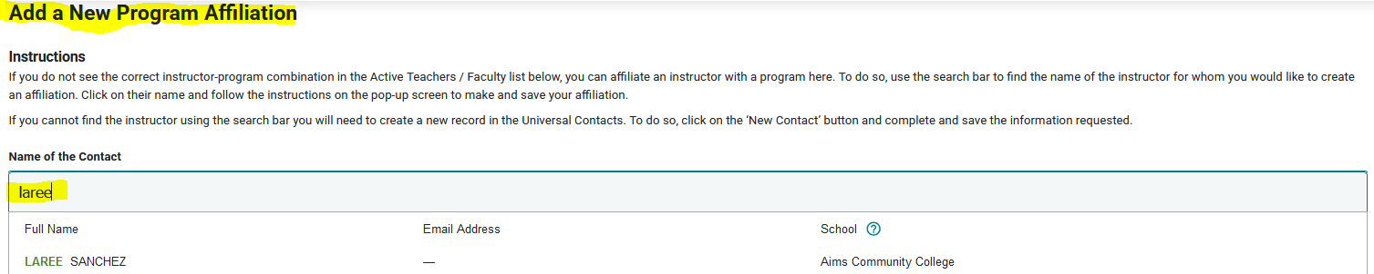

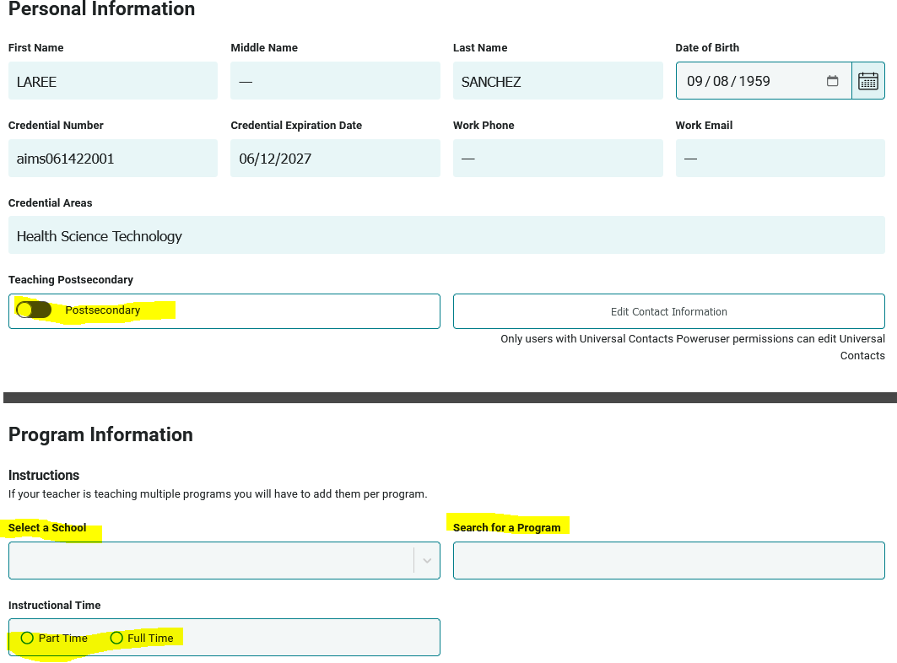

Note: It’s important to understand the CTE Gateway does not automatically Sync between Universal Contacts and Active Teachers. Therefore, if you update information for a current teacher, such as credential number and expiration date, in Universal Contacts, you will also need to update that information for them in their Active Teacher record OR you may wish to delete the old Active Teacher record and simply reaffiliate the updated Active Teacher record with their program.

- If you choose to upload a spreadsheet, you may wish to start with a list of your current Active Teachers. You may download a list from the Gateway under “Viewing Active Teachers”. These are your current Active Teachers from 2025. Update the year to 26 along with any changes to active teachers who have continued to 2026. Remove teachers no longer teaching in 2025-26 and add new teacher information.
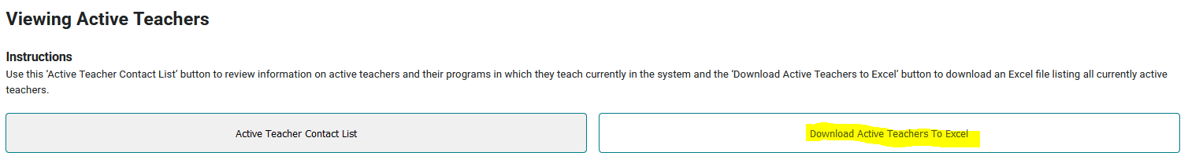
- You may also choose to start with a fresh template that you can download from the Gateway or you may use this file format documentation to build your data file in the correct Excel format for upload to the website. Note that the header names and order must match the student file layout as indicated or it will not upload into the Colorado CTE Gateway.
- Incorrect formatting or inaccurate active teacher records will trigger an error during the file upload process. You will see an onscreen error log of the first 10 errors in the file, as well as receive an email with the list of errors. Your file will not be accepted for import until all errors are corrected. Common errors include having the incorrect data year (should be 25) or programid (should match the Baseid and not the InstanceID)
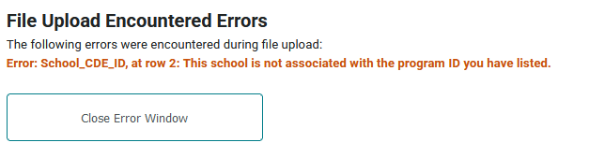

- When you upload a file, the contents of the file will update/replace all of your existing records for the current year and school. This means that the contents of your uploaded file will be inserted into the database and will overwrite any existing information for those teachers included in the file.
- Note: Not including a teacher in the uploaded Excel file does NOT DELETE previously uploaded Active Teachers. To remove any teachers who are in Active Teachers but did not teach during the 2025-26 year, you must delete them from the “View and Edit” section in the Gateway using the trash can. If a teacher leaves at the end of the school year, but taught during 2025-26, leave them in Active Teachers until the following year so you can claim expenses for CTA.
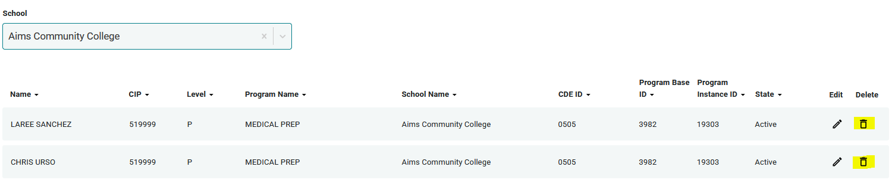
- Note that deleting a teacher from Active Teachers will NOT delete them from Universal Contacts so the history will stay intact. To inactive teachers who are no longer at your district/institution, inactive the “Active” toggle in Universal Contacts. (Note, only your district/institution Power User can change contact information)
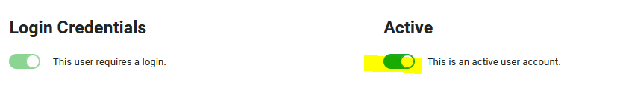
- If you have questions, you may contact cte@cccs.edu or submit an issue ticket through the Colorado Gateway.

Active Teacher Data File Format
Column  Header  (Must match Row 1 in your Excel file) | Is Data Required or Optional? | Field Coding | Field Length (number of characters)
SchoolYear | Required | The school year for which this teacher taught this program. Should be 26 for the 25/26 academic year. | 2
School_CDE_ID | Required | The 4-digit CDE or CDHE school code where the CTE program is approved. | 4
FirstName | Required | Two words separated by a space are okay. One apostrophe is allowed in the middle or at the end. Double apostrophes are not allowed. | 50
MiddleName | Optional | Two or three words separated by spaces or hyphens are okay. No apostrophes. Double spaces or hyphens, or contiguous spaces and hyphens are not allowed. | 50
LastName | Required | Can contain up to one space, one apostrophe, or one dash. Double apostrophes are not allowed. | 50
WorkPhone | Optional | Please provide a phone number when possible. This will help to prevent student record duplication in our database, and it will aid CCCS staff in contacting instructors with important information. Include the area code. All standard formats are accepted. | 20
WorkEmail | Required | Please submit a work email address for this teacher. CCCS needs these in order to keep our CTE instructors updated on important information. | 150
DOB | Required | Either MMDDYYYY with no slashes or hyphens (Ex. 09171992) or mm/dd/yyyy format (Ex. 9/17/1992). The format for all dates in the file must be the same. Do not mix formats.  We require a DOB to use it in combination with the name fields to identify specific instructors in order to avoid creating duplicate records. We use this information internally only. | 8 - 10
UniqueID | Postsecondary | Postsecondary: List S# or identifier | 9
Credential Number | Required | Include the teacher’s credential number. This allows CCCS to easily verify the credential is current. | 6 - 17
CredentialExp | Required | Include the teacher’s CTE credential expiration date. This helps both you and CCCS keep track of expiring credentials. Either MMDDYYYY with no slashes or hyphens (Ex. 01012021) or mm/dd/yyyy format (Ex. 01/01/2021). The format for all dates in the file must be the same. Do not mix formats. | 8 - 10
TimeID | Required | List whether the teacher is full-time or part-time overall. Not just CTE teacher time.  - 1 = Full-Time  - 2 = Part-Time | 1
ProgramLevel | Required | - 1 = Secondary  - 2 = Postsecondary  - 5 = Middle | 1
ProgramID | Required | 5-digit Program ID. This can be found as the far left column in the program approval section of ColoradoCTE.com | 5
CredentialArea | Required | List credential area | 500
CredentialType | Postsecondary | - 1 = Initial  - 2 = Professional | 1
RenewalReq | Postsecondary | Postsecondary: List renewal requirement(s) | 150
ContactID | Optional | If the instructor is already in Universal Contacts they have a ContactID that you could enter if you wished—it is the number in the url of their user profile: https://cccs-cte-ui.azurewebsites.net/contacts/#. However, our import process will match to the pre-existing contact record if you do not insert it here, so it is not required. | 6
End of Data File Format

Active Teacher Frequently Asked Questions (FAQ)

Screenshot of Active Teacher file:
- Why are there bold and italics in the column headers in the template I downloaded?
    - Bold fields are required during the upload process.
    - Italic fields are optional but should be reported where available.

- Why is there a little green triangle in the upper left corner of some of the cells in my Excel spreadsheet?
  - The little green triangle (see screenshot above) indicates that the data in the cell is formatted as text data in a numeric field. Excel automatically determines what type of data is in a column by looking at the first few lines of data. If the data is all numbers then Excel assumes that the entire column is numeric. If the first few lines contain dates then Excel assumes that the entire column contains dates. If the first few cells contain non-numeric text then Excel assumes that the entire column contains text data. It is recommended that once you download the template for the year to highlight the entire spreadsheet as text. You can also format the cells as text by preceding the data in the cell with a single apostrophe (‘). If you do this, then the green triangle appears. Note that all cells in a column must be formatted the same for the file to upload correctly which is why it is easiest to format all as text.

- Why do leading zeros disappear in the Excel spreadsheet?
- This is related to the discussion in 2 above. In numeric fields, leading zeros are always removed by Excel. To get the leading zero to appear you have to either format the cell as text or enter a single apostrophe in front of the number in the cell, e.g. enter ’0123 in a cell instead of just 0123. This is another reason we recommend formatting the entire spreadsheet as text after you download it.

- Why does the error report say that various fields have no value found but when I look in the spreadsheet there is a value there?
- This is closely related to the items above. If you, for instance, download the active teacher report in order to add more records to it, the data in the downloaded Excel file will generally be formatted as text. Hence numeric fields such as Program ID will be numbers formatted as text and will appear with the green triangle in the upper left corner of each cell. If you add more records and put numeric data in (no green triangle in the cell, no apostrophe preceding the value in the cell) then the validator cannot read that data. Excel looks at the first few lines, determines that the column contains text and then cannot read the numeric data you added in later rows. This works (or fails to work as the case may be) conversely as well. If you download the starter file there is no data in it. If you put numeric values in the first few rows of data then add rows with text data in the numeric columns, the validator will be unable to read the differently formatted data. The main point of this is that all the fields in any given column must be the same type – either text or numeric which is why we suggest formatting the entire spreadsheet as text.

- Do I have to put leading zeros into fields such as CDE ID and Program ID?
  - It is preferable so that data remains consistent. The data file format above shows leading zeros required in CDE_ID, and ProgramID. If you are modifying or adding records in a file that already has data in it with leading zeros (see the discussion above) then you must format your new data to match what is already in the file. So if you download the Active Teacher list and it has, for example, 01122 for program ID, then any rows you add or modify should have the leading zeros or you will get an error. If you are starting with an empty file, then format the entire file and columns as text.

- Why can’t I use a normal date in the DOB field or Credential Expiration field?
  - You can if ALL the dates are normal dates. The validator will accept dates in the format such as 1/5/1993 if all the dates in the column are done the same way. All dates should either be the eight character string such as 03302014, or all should be normal dates such as 3/30/2014.

- Can I remove columns for data we’re not submitting or rearrange the order of columns?
  - No and no. Every column of data must be in the header and in the exact order of the file layout or you will get an error on importing. Don’t change or alter the header or remove or hide columns in any manner. The exception to this is the Follow-up Student List. If you download the list from the Gateway, ALL columns will appear. However, as you can see from the data file format for Follow up, not all of those columns are required for upload. You can simply ignore any columns that are not required, or you can delete them before uploading.

- Can I include duplicate teachers in my file upload?
  - Yes, if the teacher is instructing across multiple programs or schools. You should only include one teacher record per school and program. If you include a teacher record twice for the same school and programid, you will get an error message.

- If my program is inactive, can I still report enrollment and active teachers?
  - Yes, beginning in AY 2024-25, the Gateway should allow you to report enrollment, follow up, and active teachers for any program that was active at some point between July 1, 2025 and June 30, 2026. Should you encounter an error, please submit a ticket to CTE@CCCS.edu

- If I had a teacher who wasn’t credentialed until after the school year, can I include them in Active Teachers?
  - If a teacher was credentialed AT ANY POINT between July 1, 2025 and June 30, 2026, you may report them as an active teacher and report enrollment on the program they taught. You can only report enrollment for those students taught by credentialed instructors.

- If I added a teacher by accident, will a new file upload with the teacher removed also remove the teacher from the Gateway?
  - No. If you add a teacher manually or to your file upload in error, simply removing them from the file and reuploading will NOT remove them from the Gateway. To remove a teacher, you must go into active teachers and delete the teacher manually as shown below.
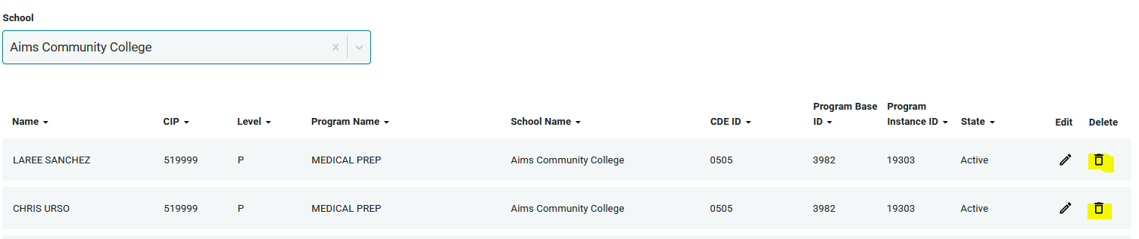

End of FAQ

