CTE Follow-up Reporting 2024-25
Submission Deadline: March 31, 2026
This file format is only for secondary CTE concentrators and postsecondary CTE completers reported for 2025. Do not use it to report on students who were not concentrators or completers in 2025.

Follow up General Information

What is Follow-up reporting?
CTE follow-up data contains placement information (employment, continuing education, etc.) on your students who were marked as secondary concentrators or postsecondary completers during the most recent academic year. Because of its ties to continued federal and state funding for CTE programs, it is critical that the data be timely, valid, complete, and reliable. All CTE data submitted to CCCS is subject to audits internally, by the state, and by multiple federal agencies. Knowing student outcomes is critical in advocating for and improving programs. Fulfilling these reporting obligations is also important to continue eligibility for program approvals and funding.

How is CTE student data used and why is it required?
- Perkins Formula Allocation Grants – CTE student enrollment data is used in a portion of the formula, which calculates the distribution of federal Perkins funds to secondary and postsecondary institutions. Perkins formula allocations are reported to the schools by CCCS in the spring of each year.
- Federal Performance Reports – CTE student information is used for the federal performance report (Perkins performance metrics) due in December of each year to the US Department of Education and also dispersed to local recipients each spring to address in their Perkins local plans. This report uses information on special populations, gender, ethnicity, and program participation, concentration, and completion information.
- Colorado Technical Act - The secondary CTE data is used to generate the Colorado Technical Act (CTA) report, which is required by the state legislature each year. This report contains information on CTE programs including enrollment, completion, placement, costs, FTE, and other items.
- Program Approval & Renewal Process - The CTE student data populates three separate 5-year trend reports used by CCCS to evaluate new and existing CTE programs as set forth by the State Board for Community Colleges and Occupational Education (SBCCOE).

- Civil Rights Compliance Audits - The CCCS internal audit department uses the CTE student information to determine which schools should be visited in a compliance visit as mandated by the U.S. Department of Education, Office for Civil Rights. Selection can include such factors as concentrations of special populations, region, size, and time of the last visit.
- Other CCCS Reports - Many other reports are produced internally throughout the year for CCCS staff in order to maintain as well as continually improve and promote CTE in the state of Colorado.

CTE Student Enrollment
The CTE student enrollment submission for most secondary institutions is created in early summer following the close of each academic year. The process involves collecting demographic and program participation, concentration, and completion status for students taking CTE courses.

CTE Student Follow-up
The CTE student follow-up data is due March 31st of each year. The follow-up process involves the gathering of placement information on students who completed a CTE program in the previous year.

What is the privacy policy of CTE student records at CCCS?
Aggregated data reports derived from CTE student records are considered to be public information with most reports mandated as such by the federal Perkins Act. Individual student records are protected in accordance with the Family Education Rights & Privacy Act (FERPA) and other established policies.

Reporting Instructions
Please read all the instructions and file field descriptions below carefully before starting your file. It is likely to save you time, limit frustration, and help to ensure that your data is complete and accurate in the long run.
- You should only report data on secondary concentrators or postsecondary completers reported for the 2025 enrollment year. To obtain a list of these students for your institution, login to the Gateway and navigate to Menu/Data Collection/Follow-up and download your list of students along with the most updated guidance. If you do not see this section of the site, your district or institution’s primary contact (Power User) will need to assign you the permission DC-Student Record.

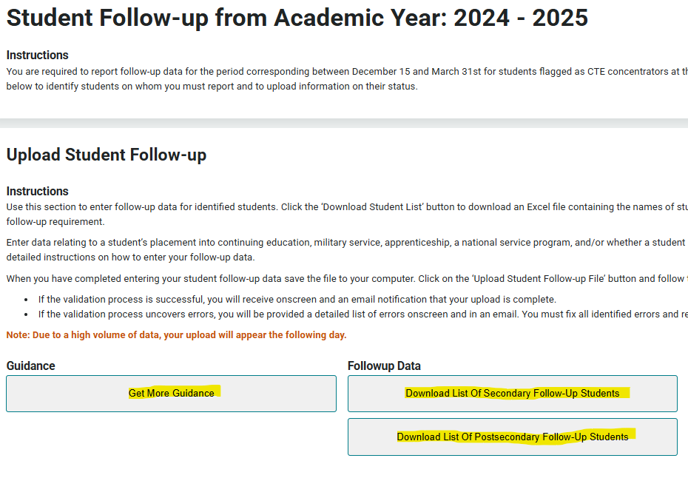
- Once you’ve downloaded the student records, review the number of students who need follow-up completed, as well as the information that needs to be collected, and decide how your institution can best collect this from every student (Online survey, phone call, text, etc.) Refer to the “Best Practices” section below to help you determine methods to use.
- Report follow-up for students even if a program closed or later became inactive. The US DOE requires you to conduct surveys on students who concentrated/completed the previous year.
- Do not start surveying students until December 1, 2025.
- Phrase all questions, excluding certification exam/passed, relative to what the student was doing during the specific window of October 1, 2025 through December 31, 2025. Refer to the “Best Practices” section below to see example survey questions to use.
- Try to collect survey information on all students in the Follow-up. We recommend shooting for a minimum 70% response rate per program. You should try to contact students at least three times before giving up.
- If a student is a concentrator or completer in multiple programs you should try to contact them only once, gather placement information relative to each program they concentrated/completed, and submit placement for every completion record in the Follow-up collection for that student.
- You may also find that the Follow-up survey relates to another industry survey you need to conduct. You are welcome to combine surveys; however, you must still include all the fields to meet the requirements of CTE Follow-up reporting.
- The Follow-up process is for ALL previous year CTE secondary concentrators or postsecondary completers regardless of grade or graduation. However, obtaining placement data for graduates is critical to showing the success of CTE. Focus first on reaching out to graduates and getting their information if it helps. Then mark your continuing secondary or postsecondary students as “Continuing Education” then follow up with them on Employment, Certifications, etc. as time permits.
- You must provide a code in the Placement, Continuing Education, Military, Apprenticeship, Service Program, Certification Exam Completed and Certification Exam Passed fields for every student in Follow-up (even if your response may be a selection for “unknown”). All these fields are extremely important for telling the story of student outcomes and program renewals.
- Please review the “Special Rules” sections in the file layout for help in determining special circumstances you may encounter with student responses.
- To report the data, you can either upload a completed spreadsheet or use the individual entry method in the Gateway. We recommend the individual entry method if there are just a few concentrators/completers in a program. Otherwise, you should use the upload method. If you report by single record entry, you will pick answers from a dropdown list for each student. If you provide a data file, then you will use the codes listed in the columns in the table below.
- Fields in the table below should be in the same order and must contain the designated header in row 1 of the file. Do not try to add any extra student records in your data file or modify the enrollment data previously submitted for the 24-25 school year. Extra student records in your data file that are not found in our database will trigger an error during the file validation process and you will need to remove them from your file.

Uploading and Validating Your Data

- Once you have finalized your file, you are ready to upload it to the Data Collection>Follow-up section of ColoradoCTE.com (The Gateway) Use the upload file button to import files. Do not email or mail your data file(s) to CCCS! Once your file is uploaded, it will be imported into the CTE data system, and you will be able to review the results within 24 hours. You’ll have the opportunity to update the data (up to the March 31 deadline) with another file if you find that you need to amend records. Note that updating records is only possible if your entity has not “certified” its records are complete and accurate in the Gateway. Do NOT certify your submission as complete until all records have been uploaded and checked for accuracy!
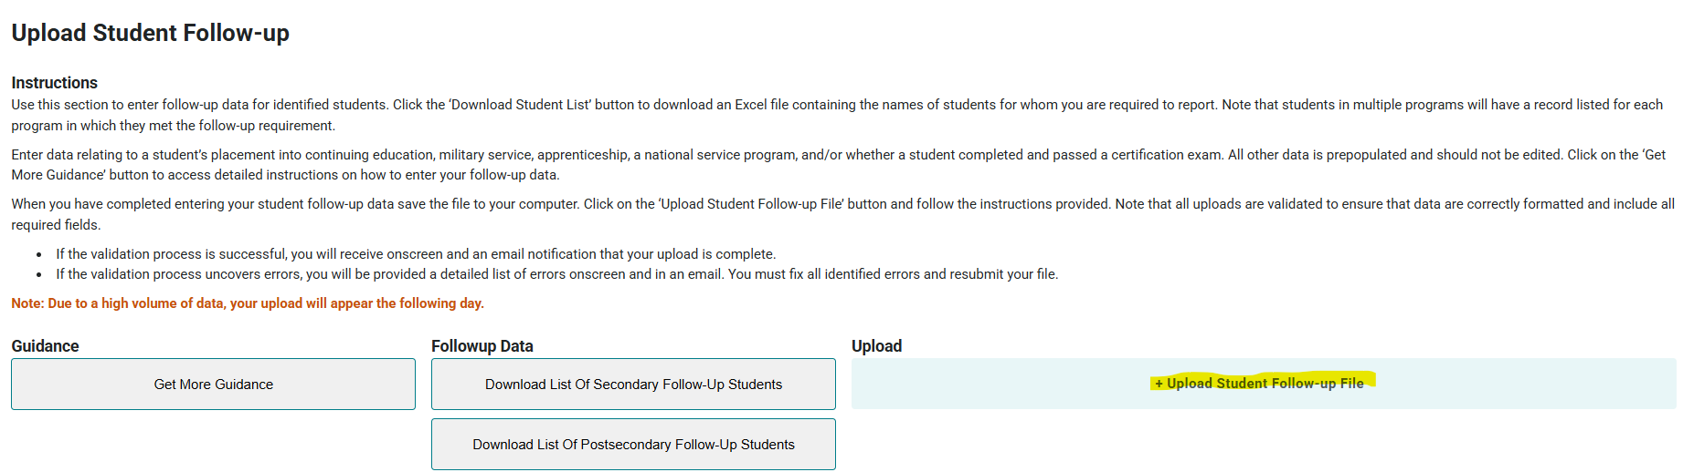
- When you upload a file, you will see an onscreen error log of the first 10 errors in the file, as well as receive an email with the list of errors. Your file will not be accepted for import until all errors are corrected. See “Common Errors and How to Fix Them” below.
- There are no specific requirements for the filename, but it is suggested that you name the file in such a way that it can be clearly distinguished from any other files that you upload, e.g. <schoolname>_<year>.xlsx.
- Access to the Data Collection section of the Colorado CTE Gateway (https://coloradoCTE.com) is granted by the district’s primary CTE contact by assigning the ‘DC – Student Record’ permission on a user profile. If you need access, reach out to your institution’s primary CTE contact. (AKA “Power User”)

Common Errors and How to Fix Them
- Exception in Data Collection: This error typically means the data year in your file upload is invalid. Check to make sure the data year is the last two digits of the current year enrollment. (For example, 2024-25 = Data Year 25)
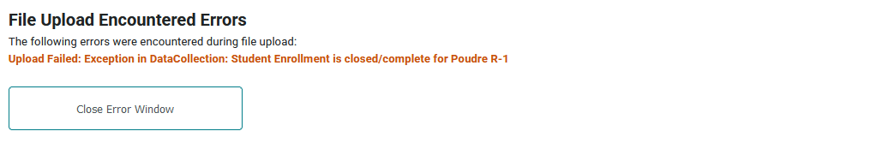
- Invalid Values: If you enter an invalid value or the length doesn’t match what the file layout requires, you will receive an error. The message will also tell you what the valid values are for you to choose from.

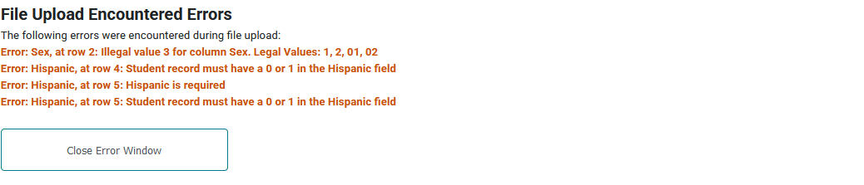

- Invalid Placement/Continuing Education Codes: If you enter an invalid combination of Follow-up codes due to any of the “Special Rules”, you will receive an error. Unfortunately, the message contains ALL special code combinations, so check the following for which one applies to your situation.

Placement = 5
Unknown: You should only use the placement status code 5 (Unknown or unable to contact) when you know nothing about the status of the student or only technical skills assessment/certification exam information is known. In other words, if you mark ‘5’ (Unknown or unable to contact) for placement, also mark unknown for Continuing Education(5), Military Service(3) Apprenticeship(3) and Service Program(2).

If you know anything else about the student outside Assessment/Certification, including Continuing Education at the secondary or postsecondary level, code those fields appropriately and change placement to ‘4’ unless one of the other “Special Rules” apply.

Military = 1
Military Full-Time: If a student is in the military full time (35 or more hours per week), you should use placement status code ‘1’ (employed related to training), mark them as continuing their education as code ‘3’ (continuing at community or technical college level), unless you know that they are enrolled at a four-year institution (and in that case enter “4” in the continuing education field), and for the military service category, mark them ‘1’ (military full time category).

Follow-Up Fields Layout
*Required fields will error if blank or if columns are missing or moved*
Column  Header  (Row 1 of your Excel file.  Must match exactly) | Field Name | Field Coding | Field Length  (Number of characters)
Placement | Placement Status  (Provide a code for every record) | At any time between October 1st and December 31st, 2025, were you:  - 1 = Employed full or part time in an occupation  related to the CTE program completed last year  - 2 = Employed full or part time in an occupation not related to the CTE program completed last year  - 3 = Unemployed and actively seeking employment  - 4 = Unemployed and not actively seeking employment (use this status if the student is not seeking employment for any reason such as by choice, volunteering, enrollment in school, illness, pregnancy, etc.)  - 5 = Unknown - unable to contact student. No follow-up information was collected on this student  - 7 = Student is deceased | 1
Special Rules for Placement:

ACE: ACE (998005) program completers—mark all students that have any type of employment with a placement status code “1” (employed related to training). Do not use status code “2” (employed not related to training).

SAE: If a student is involved in a supervised agricultural experience program (paid or unpaid), then you should use placement status code “1” (employed related to training).

Unsure: A respondent may be unsure at times whether they should be considered employed. You may explain that they are considered employed even if they are on paid leave, vacation or sick leave.

Unemployed not actively seeking: Placement status code 4 (unemployed and not actively seeking employment) can be used when the student chooses not to seek employment for any reason. The student may be ill, continuing education (secondary or postsecondary), retired, pregnant, or simply chooses not to seek employment. If the student is continuing their education and is not employed, use a Placement status code 4 and then choose one of the continuing education categories (1, 3, or 4). If you know the student is continuing education, but don’t know their employment status, you should still use placement code 4 and choose one of the continuing education categories (1, 3, or 4— see information on the field below).

Unknown: You should only use the placement status code 5 (Unknown or unable to contact) when you know nothing about the status of the student or only technical skills assessment/certification exam information is known. In other words, if you mark ‘5’ (Unknown or unable to contact) for placement, also mark unknown for Continuing Education(5), Military Service(3) Apprenticeship(3) and Service Program(2).
ContEducation | Continuing Education  (Provide a code for every record) | At any time between October 1st and December 31st, 2025, were you:  - 0 = Not continuing education  - 1 = Continuing at high school level (secondary)  - 3 = Continuing at community or technical college or similar (i.e. certificate or associate degree program or similar)  - 4 = Continuing at four-year college or university (i.e. bachelor’s degree)  - 5 = Unknown | 1
Special Rules for Continuing Education:

Note: This question pertains to where the student was primarily enrolled during the survey window (October 1-December 31) following program completion. It is not asking if the student plans to pursue a postsecondary education in the future.

Dual/Concurrent Enrollment: If the student is in a concurrent enrollment program during the survey window, then they are still primarily enrolled at the secondary level. Thus, mark them a continuing education = ‘1’.

Apprentice: If a student is in an apprenticeship program, then mark them as continuing education = ‘3’ (continuing at community or technical college level).

Military Full-Time: If a student is in the military full-time (see field below), mark them as continuing education = ‘3’ (continuing at community or technical college level), unless you know that they are enrolled at a four-year institution (and in that case enter ‘4’ in the continuing education field).
MilitaryServiceId | Military Service  (Provide a code for every record) | At any time between October 1st and December 31st, 2025, were you:  - 0 = Not in the military  - 1 = In the Military Full Time (≥35 hours/week)  - 2 = In the Military Part Time (< 35 hours/week)  - 3 = Unknown | 1
Special Rules for Military Service:
This includes active enlistment in a branch of the United States armed forces (Army, Navy, Marines, Air Force, Coast Guard, as well as Army National Guard, Air National Guard, or Active Reserves).

Military Full Time: If a student is in the military full time (35 or more hours per week), you should use placement status code ‘1’ (employed related to training), mark them as continuing their education as code ‘3’ (continuing at community or technical college level), unless you know that they are enrolled at a four-year institution (and in that case enter “4” in the continuing education field), and for the military service category, mark them ‘1’ (military full time category).
Apprenticeship | Apprentice Status  (Provide a code for every record) | At any time between October 1st and December 31st, 2025, were you:  - 0 = Not in an apprenticeship  - 1 = Participating in an apprenticeship related to the CTE program completed last year  - 2 = Participating in an apprenticeship not related to the CTE program completed last year  - 3 = Unknown | 1
Special Rules for Apprenticeship:
Definition of apprenticeship is as follows:
Apprenticeship is a work-based training model that integrates all of the following components:
  - Apprentices earn wages from their employers during training;
  - Programs provide on-the-job learning and job-related technical instruction;
  - On-the-job learning is conducted in the work setting under the direction of one or more of the employer’s personnel;
  - Training results in an industry-recognized credential.

Apprenticeship: If an individual is in an apprenticeship program (related or unrelated to CTE program), then mark them for Continuing education as ‘3’ (Continuing at community or technical college level).
ServiceProgram | National Service Program or Peace Corps  (Provide a code for every record) | At any time between October 1st and December 31st, 2025, were you:  - 0 = Not in AmeriCorps, Volunteers in Service to America (VISTA), National Civilian Community Corps (NCCC), or Peace Corps  - 1 = In AmeriCorps, Volunteers in Service to America (VISTA), National Civilian Community Corps (NCCC), or Peace Corps  - 2 = Unknown | 1
 | No “Special Rules”
CertExamCompleted | Industry Certification or License Exam Completed  (Part 1) (Provide a code for every record) | - 0 = Unknown  - Y = During the program completion year or since leaving school student has taken a state licensing test or an industry certification test related to the  - program completed  - N = During the program completion year or since leaving school student has not taken a state licensing test or an industry certification test related to the program completed | 1
CertExamPassed | Required | - 0 = Unknown or No to Part 1.  - Y = If yes to Part 1, and student did meet the requirements for licensure/certification.  - N = If yes to Part 1, and student did not meet the requirements for licensure/certification. | 1
Special Rules for Industry Certification or License Exam:
If certification exam completed is ‘unknown’ (0) then fill in certification exam passed as ‘unknown’ (0).

End of File Layout

Survey Questions to Use

Many schools opt to issue an online survey (using Survey Monkey or Google forms, for example) as one way to reach respondents. Some schools integrate follow-up related questions within broader surveys. The following survey question examples are provided to help you phrase your questions if you find you need inspiration.

First, of course, determine the best way that works for you to gather individual student information (i.e. identifying information for individual student, identifying the program, etc., though it may also be an automated option within your survey tool to track respondents).

Consider including phrasing or text around why we conduct these surveys. As in: Student outcomes trends are important for us to understand so we are able to advocate that Career & Technical Education is a valuable and worthwhile use of government funds. Your answers will be confidential and will be used in fulfilling reporting requirements in order to help us continue to fund these programs.

At any time between October 1st and December 31st, 2025:
Were you employed?
- Employed full or part time in an occupation related to the program I completed last year
- Employed full or part time in an occupation not related to the program I completed last year
- Unemployed and actively seeking employment
- Unemployed and not actively seeking employment (this may be for any reason such as by choice, enrollment in school, volunteering, illness, pregnancy, etc.)

Were you enrolled in an educational program?
- Attended high school
- Attended community or technical college or similar (i.e. enrolled in a certificate or associate degree program or similar)
- Attended a four-year college or university (i.e. enrolled in a bachelor’s degree program)
- Not enrolled in any education

Were you in the military?
- In the military full-time (greater or equal to 35 hours/week)
- In the military part-time (less than 35 hours/week)
- Not in the military

Were you in an apprenticeship?
- Participated in an apprenticeship related to the program I completed last year
- Participated in an apprenticeship, but it is not related to the program I completed last year
- Not in an apprenticeship

Were you participating in AmeriCorps, Volunteers in Service to America (VISTA), National Civilian Community Corps (NCCC), or the Peace Corps?
- Yes
- No

Have you completed an industry certification or licensure exam during or after you completed your program?
- Yes
- No

If you answered “yes” to the previous question, did you meet the requirements for licensure or certification?
- Yes, I passed the exam/met the requirements for licensure and/or certification.

Comparison of Different Contact Methods and Best Practices

General Best Practices
- Best practices in Follow-up actually begins six months BEFORE Follow-up is to be done. The first critical steps are to one, inform teachers of the critical nature of collecting outcomes data, and two, have the teachers collect student contact information including a student’s personal email (Not school email) and cell phone BEFORE the students depart campus in May. Have the teachers inform the students that they will be contacted later in the year and also stress the importance of outcomes data.
- Determine ahead of time, around December 1 or early in January, who will conduct the surveys, the methods they will employ, and the dates involved.
- If you have more than one person conducting surveys, hold a brief training so all involved know how to phrase the questions and conduct the surveys consistently.
