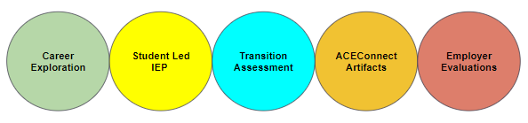

- Four Career Exploration or Transition-Related Activity & Service Events
- CareerX event (via ACEConnect, CareerConnect, or school-run) reflection
- College tour reflection
- Virtual Job Shadow

2. Yearly Student Led IEP
- Check out an example template
- See the suggested rubric HERE

3. Yearly Transition-Related Assessment
- Check out our Assessment Finder Tool
- Sign up for ACEConnect supported assessments HERE

4. Four ACEConnect Course Artifacts
- ACEConnect courses and competencies
- Ideas for activities & artifacts

5. Four Final Employer Evaluations
- In-school businesses, service learning, paid or unpaid internships, competitive employment
- Final employer evaluation template

WHO QUALIFIES? See the guide to determining if a student is
Significantly Impacted Academically.

ACE Competencies
- Academic Foundations  - Communication  - Critical Thinking  - Information Literacy  - Systems  - Safety, Health & Environmental | - Leadership & Teamwork  - Ethics & Responsibilities  - Employability & Career Development  - Technical Skills  - Independent living

Resources
- New graduation requirements Quick Reference
- Graduation Guidance Document for Students with Disabilities
- Capstone Portfolio Guidebook
- Exemplar Google Portfolio
- IDEA vs Section 504/ADA Document
- Sign up for the ACEConnect EPIC Newsletter.
- Access funding! Let us know if you’d like more information on ACE Program Approval or Teacher Credentialing HERE.
- Sign up for FamilyFoundations workshops HERE.
- Sign up for CareerX events - coming soon!
- Check out the ACEConnect Transition Services website for more information.
- Capstone Portfolio through Work Experience Schoology course
  - Coming soon!

- Check or add to the live FAQ HERE.
- Have a print-out of this document, and would like to access the hyperlinks?
Find the digital version at https://tinyurl.com/CPTWE-Ref

