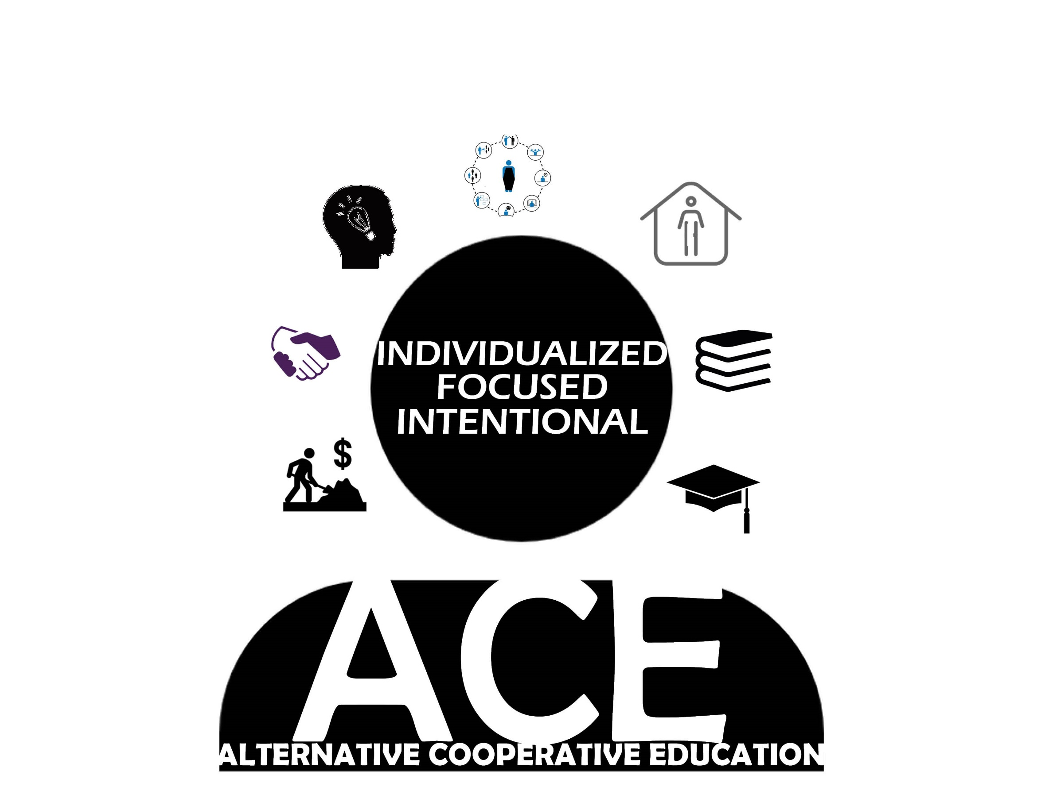

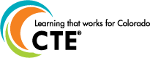

BUSINESS AND INDUSTRY
Collaborates with business and industry to enhance student employability with a stronger under- standing of employer expectations in order to develop professional and technical skills of students.

WORK BASED LEARNING (WBL)
Facilitates opportunities within the community, in school, volunteering, internships, apprenticeships and/or supported employment to emphasize the development of professional as well as industry specific technical skills.

CAPSTONES
Promotes a meaningful course sequence to meet graduation requirements

ACADEMIC FOUNDATIONS
Integrates intentional curriculum within State CTE and Academic standards aligned with current practices and expectations.

INDEPENDENT LIVING
Develops social and emotional skills that enhance students understanding of how to productively live on one’s own with a sense of personal and civic responsibility.

POSTSECONDARY WORKFORCE READINESS (PWR)
Develops knowledge, skills, and competencies to promote employability, postsecondary and lifelong learning.

CAREER DEVELOPMENT (ICAP)
Provides a multi-year process that intentionally guides students in the exploration of career, academic and postsecondary opportunities.

